Preliminary Design Review Document

By

Ian Adelman,

Devin Hoopes,

Natalie Gonzalez

Alex Reinert

Submitted to Dr. Isenberg and Dr. Jonathan Adams

of Embry-Riddle Aeronautical University

in Partial Fulfillment of the Course Requirements for ME 407 and COM 420

December 8, 2023

**ABSTRACT**

The Atlas system aims to aid workers in the moving industry by creating an automated system to carry heavy loads up and down the stairs with minimal physical effort from the operator. The Atlas system does so by utilizing a set of four actuated legs to climb up the stairs while the payload is strapped to the top. In order to ensure operator safety, the system will be remotely controlled with an emergency stop that can be activated at any time during operation. In this document, the design requirements for the Atlas system will be provided, with their respective specifications included as well. The Atlas system design and its compliance with the design requirements will be detailed in full, with justifications for each. The design described in this document is to be built at a quarter scale as a proof of concept but could potentially be scaled up to a full-sized product.

# TABLE OF CONTENTS

TABLE OF CONTENTS iii

LIST OF FIGURES v

LIST OF TABLES v

LIST OF EQUATIONS vi

1.0 INTRODUCTION 1

1.1 Problem Statement 1

2.0 REQUIREMENTS AND SPECIFICATIONS 2

2.1 Functional 2

2.1.1 The system shall transport furniture repeatedly up and down one floor within a residential building. 2

2.1.2 The system shall accommodate up to a 3-seater sofa. 2

2.1.3 The system shall accommodate up to a 5-shelf bookshelf. 2

2.1.4 The system shall be reusable. 2

2.2 Sizing 2

2.2.1 The system shall fit within the stairwell in the front of the STEM building. 2

2.2.2 The system shall be transportable in the back of an average moving van. 3

2.3 Safety 3

2.3.1 The system shall cause less injury and strain than an average moving job. 3

2.3.2 The system shall not destructively alter the environment. 3

2.3.3 The system shall not damage the furniture. 3

3.0 PRELIMINARY DESIGN 4

3.1 Main Chassis 4

3.2 Motor Block 5

3.3 Leg Assembly 7

3.3.1 Forward and Inverse Kinematics 8

3.4 Equations of Motion 12

3.5 Dynamical Simulations of the Open-Loop System 16

3.6 Control System 17

3.7 Dynamical Simulation of the Closed-Loop System 17

3.8 Structural Analysis 17

4.0 ELECTRONICS 19

4.1 Electrical Schematic 19

4.2 Printed Circuit Board Layouts (PCB) 19

4.3 System Flowchart 19

5.0 PROJECT MANAGEMENT 20

5.1 Current Status 20

5.2 List of Components 21

6.0 CONCLUSION 21

7.0 REFERENCES 22

APPENDIX A: CAD Drawings 25

APPENDIX B: Forward and Inverse Kinematic Equations 41

APPENDIX C: Bill of Materials 42

C.1 Custom Components 42

C.2 Fasteners 42

APPENDIX D: Control Flow Chart 42

APPENDIX E: Average Couch and Bookshelf Weights and Dimensions 44

E.1 Bookshelves 44

E.2 Couches 44

E.3 Stairway Dimensions 44

APPENDIX F: Electrical Schematic 45

F.1: TOP LEFT 45

F.2: TOP MIDDLE 46

F.3: TOP RIGHT 47

F.4: BOTTOM LEFT 48

F.5: BOTTOM MIDDLE 49

F.6: BOTTOM RIGHT 50

APPENDIX G: Printed Circuit Board (PCB) Layout 51

APPENDIX H: System Flowchart 52

APPENDIX I: Dynamics Simulation and Control 53

# LIST OF FIGURES

Figure 1.1: Chart of Workplace Accidents 1

Figure 3.1: Full System Assembly 4

Figure 3.2: Main Chassis 4

Figure 3.3: Motor Block 5

Figure 3.4: Drive Screw Mechanism 6

Figure 3.5: Pulley and Screw Force Diagram 6

Figure 3.6: Leg Assembly 7

Figure 3.7: Leg Pulley Configuration 7

Figure 3.8: Atlas Leg Inverse Kinematic Diagram 11

Figure 5.1: Detail Design Gantt Chart 21

# LIST OF TABLES

Table 3.1: Points of Failure and Corresponding Failure Loads 18

Table 5.2: Compiled List of Components with their Respective Costs and Vendors 21

Table B.1: Relative Position Vectors and Rotations of System. 41

Table C.1: Custom Components 42

Table C.2: Fasteners Components 42

Table E.1: Bookshelf Characteristics 44

Table E.2: Couch Characteristics 44

Table E.3: Dimensions of Stairs in Bldg. 76 44

# LIST OF EQUATIONS

(1) Rotation Matrix about X-axis Definition 9

(2) Rotation Matrix about Y-axis Definition 9

(3) Rotation Matrix about Z-axis Definition 9

(4) Rotation Matrix Product from I to N 9

(5) Example Rotation Matrix Product 9

(6) Example Position Vector Addition 10

(7) Example Position Vector Addition with Reference Frame Correction 10

(8) Example Position Vector Addition with Reference Frame Correction Simplified 10

(9) Planar Two-link Inverse Kinematic Solution Part 1 11

(10) Planar Two-link Inverse Kinematic Solution Part 2 11

(11) Planar Two-link Inverse Kinematic Solution Part 3 11

(12) Generic Equation of Motion 12

(13) Generic Kinetic Energy Equation, Scalar Form 12

(14) Generic Kinetic Energy Equation, Matrix Form 13

(15) Generic Kinetic Energy Equation, Matrix Form, Expanded 13

(16) Generic Kinetic Energy Summation 13

(17) System Mass Matrix Derivation 13

(18) Vector of Coriolis and Centripetal Terms Derivation 14

(19) Potential Energy Derivation 14

(20) Potential Energy Summation 14

(21) Vector of Gravitational Forces 14

(22) Ground Contact Forces, Task Space 15

(23) Ground Contact Forces, Joint Space 15

(24) Force Summation 15

(25) System Accelerations 16

(26) System Acelerations Expanded 16

(27) Max Tensile Force - Cable 17

(28) Max Shear Force - Leg 18

(29) Max Bending Force - Shaft 18

(30) Max Bending Force - Bracket 18

# LIST OF NOMENCLATURE

vector originating at B and terminating at C measured with respect to frame A

direction cosine matrix with columns that are the unit-basis vectors of frame B measured with respect to frame A

angular velocity of coordinate frame B relative to frame C measured with respect to frame A

matrix of moments of inertia and products of inertia of body B measured with respect to frame A

vector of first mass moments of body B measured in with respect to frame A

mass of body/particle i

the chosen inertial reference frame

the target frame

the main body frame

angle about the y-axis of the frame of joint A1

angle about the y-axis of the frame of joint A2

desired end effector coordinate in the z-axis direction

desired end effector coordinate in the y-axis direction

imaginary triangle side 1 length for trigonometric calculation

imaginary triangle side 2 length for trigonometric calculation

the configuration coordinates of the system

the system mass matrix

vector of Coriolis and Centripetal terms

vector of joint forces and torques

kinetic energy for body   
 velocity of body

velocity of body with respect to inertial frame

the vector of joint velocities

gravitational potential energy of body

gravitational constant = 9.81 m/s/s (on earth)

total gravitational potential energy of the system

vector of forces due to gravity

the point where the wheel contacts the ground

Proportional gain

Derivative gain

= Maximum sustainable weight  
F = Failure load  
r = Radius  
 = Mass   
L = Length  
 = Ultimate shear stress  
A = Area  
I = Moment of inertia  
= Radius   
 = Yield strength

= Maximum Force  
 = Yield Strength   
b = Cross Sectional Width  
h = Cross Sectional Height

# INTRODUCTION

Below is the introduction to the Atlas system and the problem statement it was designed to address.

## Problem Statement

Transporting heavy furniture up and down the stairs is difficult and potentially dangerous.

The data on nonfatal work injuries, highlighting occupations with high injury rates, underscores the pressing need for safer workplace practices. Occupations such as transportation, production, and maintenance often involve manual handling of heavy objects, contributing to a substantial number of injuries as shown in Figure 1.1 [1] below:

Figure 1.1: Chart of Workplace Accidents

The Atlas Team's project, introducing a robotic solution for moving furniture upstairs, is a timely response to this problem. By addressing the inherent risks associated with manual labor, particularly in tasks requiring the movement of heavy items on staircases, the project aims to significantly reduce work-related injuries. The remote-controlled robotic system prioritizes operator safety, aligning with broader occupational safety goals to minimize human exposure to hazardous conditions. Overall, the project's significance lies in its potential to enhance workplace safety, decrease injury rates, and promote the well-being of workers across various occupations. Through automation, the project provides a forward-thinking solution to a prevalent issue, offering a transformative approach to manual tasks that pose risks to human health and safety in the workplace.

# REQUIREMENTS AND SPECIFICATIONS

In this section, the requirements and specifications will be laid out in the following categories: Functional, Sizing, and Safety.

As a statement of fact, the system will be built at a quarter scale with all dimensions and parameters determined appropriately to that scale.

## Functional

To achieve the goal set by the problem statement, the requirements of function are as follows:

### The system shall transport furniture repeatedly up and down one floor within a residential building.

* The overall weight placed on the legs shall not exceed 81.1 pounds to ensure the system’s capacity to support its own weight and climb up the stairs. This specification can be tested directly via a scale to measure the specified components’ weights.

### The system shall accommodate up to a 3-seater sofa.

* From Appendix E, the average couch weighs about 2.56 pounds and is roughly 22.28 inches wide by 8.90 inches deep by 8.80 inches high. To hold the requisite furniture, the main platform shall not be smaller than 22.28x8.90 in in size.

### The system shall accommodate up to a 5-shelf bookshelf.

* From Appendix E, the average bookshelf weighs about 1.02 lbs., and it is roughly 7.52 in wide by 3.13 inches deep and 16.34 in high. To hold the requisite furniture the main platform shall not be smaller than 22.28x8.90 in in size. These specifications can be tested via direct measurement of dimensions.

### The system shall be reusable.

* The system will have a rechargeable battery that shall provide at least 1A to provide sufficient current for the system.
* The battery must be rechargeable.
* The battery must be removable for maintenance purposes.

## Sizing

To ensure that the system is of a proper size that is capable of being transported and capable of fitting within the stairwells it operates in, the requirements of interface are as follows:

### The system shall fit within the stairwell in the front of the STEM building.

* Based on the dimensions listed in Appendix E, the model stairs will be 18.88 inches high by 24.13 inches long with a landing depth of 30 inches and a handrail width of 22.50 inches. For the system to fit in the model of the stairs it shall not exceed an area 30 inches long by 22.50 inches wide.

### The system shall be transportable in the back of an average moving van.

* Based on the average sizes of a moving van [2] the maximum area is 16.5 inches by 30 inches. The system shall not exceed the maximum dimensions of a moving van.

## Safety

To ensure that the system is overall safe, and does not endanger the operator or environment, the requirements of safety are as follows:

### The system shall cause less injury and strain than an average moving job.

* The system shall remain controllable from a distance of at least 6 feet away from the operator. This can be tested by direct measurement of distance from the operator to the system, combined with a simultaneous test of control functionality.
* The system shall take no longer than half a second to stop once the emergency stop is engaged.

### The system shall not destructively alter the environment.

* In order to prevent the system from tipping over the center of mass shall not be located closer than 2.2 inches away from the edge of the support polygon at any point during operation. This specification can be tested via simulation to determine the location of the center of mass throughout a simulated trial.

### The system shall not damage the furniture.

* The brackets are located along the sides of the main platform and shall ensure safety from the furniture to slide off onto the stairs or any other part of the environment. The brackets shall be capable of supporting at least 2.5 pounds.

# PRELIMINARY DESIGN

In the following sections the robotics hardware, and all relevant analysis and diagrams will be defined in accordance with the design requirements and their associated specifications. Below in Figure 3.1, the full system is pictured.

Motor Block

Leg Assemblies

Main Chassis

Figure 3.1: Full System Assembly

The Atlas system utilizes a set of four robotic legs to safely carry its payload up the stairs, with each major subcomponent labelled and described later in subsequent subsections. All part drawings and dimensioning can be found in Appendix A.

## Main Chassis

Pictured below in Figure 3.2 is the main chassis of the Atlas system, and all subcomponents thereof.

10in

25in

Aluminum  
Extrusions

Brackets

Cargo Bed

Backing

Figure 3.2: Main Chassis

The chassis of the Atlas system is designed to accommodate a couch [2.2.1] and bookshelf [2.2.2], and as such has a width of 10 inches and a length of 25 inches at its widest point (see Appendix A, drawing 1 for more details), fulfilling sizing specifications [2.3.1] and [2.3.2]. The chassis also utilizes slotted aluminum extrusions as its main structure, as well as to provide a mounting point for the leg plates shown in section 3.4, as well as provide overall strength. Additionally, located along the sides of the bed are brackets designed for holding any securing straps used in the loading process.

## Motor Block

Pictured below in Figure 3.3 is the motor block, with each major subsystem and component labeled.

Back Pulley

Screw Plate

Motor

Figure 3.3: Motor Block

Located within the chassis, the motor block provides all the force required to actuate the legs via a drive screw and pulleys. The tendons are attached to the screw plate, which is in turn driven by the drive screw, moving the plate forward and backwards, pulling the tendons. The drive screw mechanism is illustrated below in Figure 3.4.

Central  
Plate

Lead Screw

Motor

Figure 3.4: Drive Screw Mechanism

The screw is powered by a Pololu 37D 70:1 motor and moves the central plate forward and backwards. The motor-screw system can theoretically provide up to 935lb when the motor is stalled, but the bicycle cable tendons will snap before even half of that force is reached [3].

To create a proper torque force, where one tendon pulls while the other slacks, one tendon is routed backwards to the rear pulley as pictured in Figure 3.5.

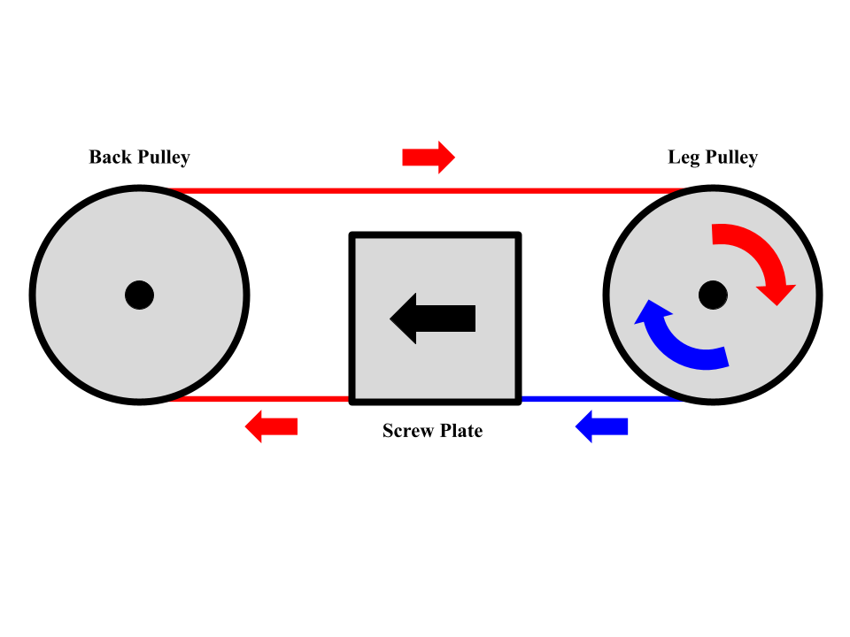

Figure 3.5: Pulley and Screw Force Diagram

The benefit of using a drive screw and tendons is that it creates a system that is non back drivable, which is to say that if power is cut from the system, it will simply stay locked in place. This allows the emergency stop to act a lot faster than software by simply cutting the power rather than executing a series of commands through software.

## Leg Assembly

Attached to the sides of the chassis by the mounting plate, the leg is the system’s main source of locomotion.

Figure 3.6: Leg Assembly

The legs are actuated via a set of tendons pulled by the motor block as previously described. The upper pulleys are used to route tendons to the lower leg segment to ensure no slack in the system by maintaining a constant distance to the lower leg. This routing configuration can be seen below in Figure 3.7.

Figure 3.7: Leg Pulley Configuration

If the upper pulleys were absent from the design, the tendons pulling the lower leg segment would slack or grow taut as the upper segment moves closer and further from the motor block respectively. Attached to the bottom segment of the leg is a powered wheel which is used both to easily navigate across flat ground to or from the stairwell, and to aid in the climbing process by allowing precise linear motion.

### Forward and Inverse Kinematics

The Atlas system must have some degree of knowledge of its state at any point in time for use in driving as well as stepping motions, and for the balancing of the system. For this, there are methods of calculations used such as the Forward and Inverse Kinematics which will be talked about in this section, and more which will be mentioned as they come up.

Firstly, the notation for many of the equations is shown below in the Notation section. This serves as a reference for what variables and values mean what for which equations.

Notation:

vector originating at B and terminating at C measured with respect to frame A

direction cosine matrix with columns that are the unit-basis vectors of frame B measured with respect to frame A

angular velocity of coordinate frame B relative to frame C measured with respect to frame A

matrix of moments of inertia and products of inertia of body B measured with respect to frame A

vector of first mass moments of body B measured in with respect to frame A

mass of body/particle i

The nomenclature standards are generic methods of describing robotic systems that can be used for any robot and serve to remove the need to re-explain each new variable, as many of the same type will be used in the below sections.

Therefore, in accordance with the nomenclature standards above, the Atlas system’s geometry is defined through position vectors and rotation matrices, which are later used in the equations of motion and dynamics calculations. Each of these values can be found in Appendix B in Table B.1: Relative Position Vectors and Rotations of System.

Furthermore, shorthand is used for rotation sequences. To rotate a frame from one orientation to another, three angle values are used, these can be expressed by rotating about the x, y, and z axes of a given frame. These rotations can be combined by multiplying them together, given they are measured with respect to the same frame.

So, when calculating rotation sequences, the following equations are defined for any angle as:

|  |  |  |
| --- | --- | --- |
|  |  | (1) |
|  |  | (2) |
|  |  | (3) |
|  |  |  |

|  |  |  |
| --- | --- | --- |
|  |  |  |
|  |  | (4) |

So then, multiplying together any set of these rotation matrices will result in one rotation matrix which has the combined rotation of all of the components. This is useful, as it allows for the calculation of orientations of links with respect to any other link. Using this method, the orientation of the Nth frame can then be expressed generally as:

Where:

the chosen inertial reference frame

the target frame

This description simplifies the system mathematically, allowing for more concise description, and additionally allows for faster computation, as combining many rotation sequences into far less, greatly increases speed.

Understanding the representation of rotations, Therefore, the orientation of the Atlas system wheel frame for leg A can be described as:

|  |  |  |
| --- | --- | --- |
|  |  | (5) |

Where:

the chosen inertial reference frame, which will not be re-defined again.

the main body frame

the first, second, and third frames respectively of leg A of the Atlas system.

This equation is describing how the wheel is oriented if it were to be measured with respect to the inertial frame. This will be useful as it allows for conversion between the angles of each joint, which can be simply found through the electrical encoders, to be transposed into the inertial frame, allowing the system to know where its points are in 3D space for any given set of joint angles.

By these methods, the orientation of any frame in the Atlas system can be described with respect to any other frame by a series of DCM multiplications, and this then allows also for the calculation of the position vectors of any point within the Atlas system with respect to any frame. If the rotation sequence is known, vectors measures with respect to a more local frame, i.e. geometry vectors, can be transformed and expressed with respect to the inertial frame, allowing for many calculations not possible without being in a more removed frame. For example, the position of the wheel of leg A, with respect to the inertial frame is shown below:

|  |  |  |
| --- | --- | --- |
|  |  | (6) |
|  |  |  |

The above equation calculates the position vector of the wheel of A3, but each vector is measured with respect to it’s local frame, and must be transformed into the target frame for valid calculation, as shown below:

|  |  |  |
| --- | --- | --- |
|  |  | (7) |
|  |  |  |

Then simplifying each rotation sequence as described above in equation (7) yields:

|  |  |  |
| --- | --- | --- |
|  |  | (8) |
|  |  |  |

For this equation, all position vectors besides the output vector in are known constants from geometry, and DCMs rely on the input robot state, making solving for the pose of any frame in the Atlas system quick and simple computationally. Code for calculating all necessary vectors and DCMs can be found in Appendix B, Table B.2: Code Repository Location.

From this point, given an input vector of joint angles, the pose of any frame in the Atlas system is solvable. Though conversely for the purposes of control, being able to pick a point in space for the legs of the Atlas system to reach and generating the joint angles required to achieve said point is necessary. This solution is met by the Atlas system’s Inverse Kinematics.

The Inverse Kinematics of the Atlas system’s four legs are calculated Analytically through trigonometry. The method of calculation, as discussed below, is the known Planar Two-Link Inverse Kinematics Solution .

Figure 3.8 below, displays is a diagram of leg A of the Atlas system, displaying how the used angles are defined and which lengths are used for the Planar-Two-Link solution.

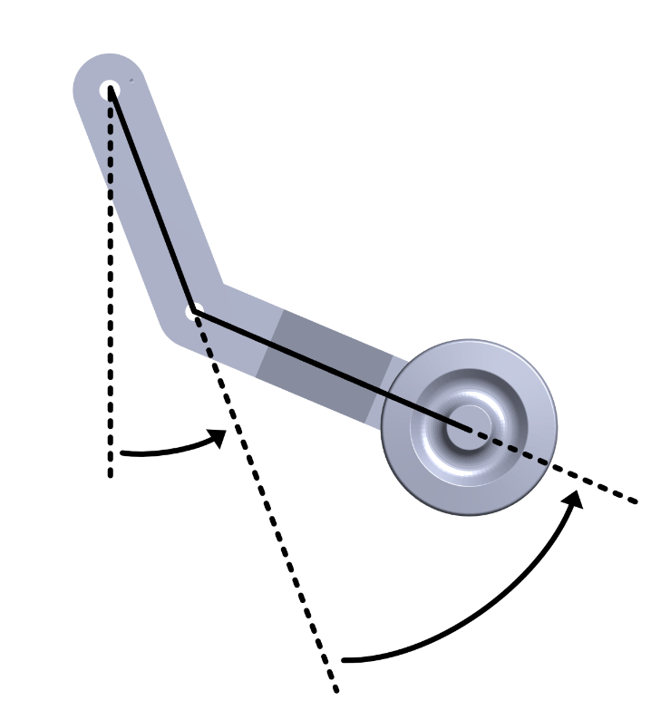

Figure 3.8: Atlas Leg Inverse Kinematic Diagram

as shown above, the two triangles made by each of the Atlas system’s legs create a two-link manipulator, which can then be solved using the quadrant corrected arctangent trigonometric function, yielding two possible solutions which can be picked from depending on the desired orientation. The equations for this are shown below:

|  |  |  |
| --- | --- | --- |
|  |  | (9) |
|  |  | (10) |
|  |  | (11) |

Where:

angle about the y-axis of the frame of joint A1

angle about the y-axis of the frame of joint A2

desired end effector coordinate in the z-axis direction

desired end effector coordinate in the y-axis direction

imaginary triangle side 1 length for trigonometric calculation

imaginary triangle side 2 length for trigonometric calculation

The above equation’s derivation is referred from [4].

This equation yields two solutions to be picked from, an ‘elbow up’ or ‘elbow down’ solution as is more casually used. And when path planning, the result of two solutions is quite valuable. Even though the wheel position may be the same from one solution to another, the position and orientations of the intermediary frames could be wildly different, potentially either creating or solving many issues.

## Equations of Motion

Now, to determine the characteristics inherent to the system and how they effect and are affected by forces and torques, several variables must be calculated. To accomplish this, the equations of motion are needed.

The equations of motion for a multi-body system can be expressed as shown below :

|  |  |  |
| --- | --- | --- |
|  |  | (12) |

Where:

the configuration coordinates of the system

the system mass matrix

vector of Coriolis and Centripetal terms

vector of joint forces and torques

These values can be determined through calculating the kinetic energy of the system. Assuming a rigid body, the kinetic energy of a body , can be written as:

|  |  |  |
| --- | --- | --- |
|  |  | (13) |

Where:

kinetic energy for body   
 velocity of body

This relationship shows the connection between the mass and velocity of the body, which are both characteristics that effect the System Mass matrix and vector of Coriolis and Centripetal terms.

Re-written into matrix form yields:

|  |  |  |
| --- | --- | --- |
|  |  | (14) |

Where:

velocity of body with respect to inertial frame

While the relationship remains the same, the method of matrix operations including multiplication require the velocity term to be ‘squared’ as in equation (14), but in matrix form that operation is done by multiplying the transposed and normal versions of the vector together, as shown above.

The expression can then be expanded and simplified to reach:

|  |  |  |
| --- | --- | --- |
|  |  | (15) |

Re-writing as shown allows for categorizing of each term, as shown with the labels above. Visually, it is now visible how the different actions of each body in the system can and will effect the system’s dynamics. Translational motion, motion due to linking between bodies, and motion due to rotating all sum together within and across all bodies to yield kinetic energy, which will then aid in deriving the System Mass matrix and vector of Coriolis and Centripetal terms, along with how the system interacts with forces and torques applied externally or by the motors of the system.

Moving forward to the overall view, the kinetic energy of the system as a whole can be expressed as the sum of the kinetic energy for each body as:

|  |  |  |
| --- | --- | --- |
|  |  | (16) |

Each individual body containing all its properties inherent to material, location, orientation, etc add together providing a single variable which allows for simple derivation of other important characteristics, such as , the system mass matrix, which can be derived from the overall kinetic energy as:

|  |  |  |
| --- | --- | --- |
|  |  | (17) |

Where:

the vector of joint velocities

This value is necessary for computation as without it, the dynamics of the simulated system would not match reality. Next, , the vector of Coriolis and centripetal terms can also be derived from kinetic energy:

|  |  |  |
| --- | --- | --- |
|  |  | (18) |

This variable is also necessary for computation, for the same reasons, the simulation would be wildly inaccurate if it was neglected.

Additionally, from equation (12) is comprised of multiple components respective to the forces they represent. For the Atlas system, is a sum of any applied external forces, Gravitational forces, Viscous friction, Coulombic Friction, and ground contact forces.

The Gravitational forces are calculated as the forces exerted by gravity on each link, which are then transformed into the joint space as torques to cancel out any dynamics due to gravity. Firstly, the potential energy is calculated:

|  |  |  |
| --- | --- | --- |
|  |  | (19) |

Where:

gravitational potential energy of body

gravitational constant = 9.81 m/s/s (on earth)

Then the total gravitational potential energy of the system can be written as a sum of the energy of each body:

|  |  |  |
| --- | --- | --- |
|  |  | (20) |

Where:

total gravitational potential energy of the system

With the total gravitational potential energy of the system, the forces due to gravity can be calculated as:

|  |  |  |
| --- | --- | --- |
|  |  | (21) |

Where:

vector of forces due to gravity

Lastly, the ground contact forces are derived. The ground forces are four forces that act on the wheel of each leg when the wheels come into contact with a ground plane. They serve to simulate a surface for the Atlas system to stand on.

Firstly, the forces to be placed on the ground contact points are calculated:

|  |  |  |
| --- | --- | --- |
|  |  | (22) |

Where:

the point where the wheel contacts the ground

Proportional gain

Derivative gain

The proportional and derivative gains are constants defined to multiply against the vertical distance from the ground, and the vertical velocity off the ground respectively, in order to keep the wheels of the Atlas system on the ground.

The Force vector component containing the ground forces can then be calculated using leg A as example by:

|  |  |  |
| --- | --- | --- |
|  |  | (23) |

Where:

the Geometric Jacobian of the wheel of leg A calculated via recursive forward kinematics [5]

In this equation, the transposed Jacobian is used to transform the forces on the legs from the inertial frame into the joint space, thereby allowing them to be expressed as torques, which can be applied or countered by the motors.

With all components of the forces calculated, the total force vector can be calculated as a sum of the individual components:

|  |  |  |
| --- | --- | --- |
|  |  | (24) |

The Atlas system uses these methods, with a Recursive Forward Kinematics Solution , to calculate the derivative of the system’s state. This then is used in combination with controls in the following section, to solve for the system’s state, as will be discussed in the next section.

## Dynamical Simulations of the Open-Loop System

The open loop dynamical simulation of the Atlas system utilizes numerical calculation with recursive forward kinematics generation. The forward kinematic solution as described above in section 3.3.1, is used in concert with the equations of motion calculated above in section 3.4 and is repeated across a given time domain for every given timestep.

With all forces accounted for in simulation, equation (12) can then be solved for , yielding the configuration accelerations of the system as shown below:

|  |  |  |
| --- | --- | --- |
|  |  | (25) |

It is at this point that additional variables may be added onto the dynamics. For example, here shows an addition of Gravitational forces on the system, Viscous friction, and Coulombic friction.

|  |  |  |
| --- | --- | --- |
|  |  | (26) |

Where:

forces and/or torques due to gravity.

Viscous friction

Coulombic friction

the signum of

Now that can be obtained, the simulation itself can be written. The method used for the Atlas simulation is a 4th order Runge-Kutta integrator, used in combination with the equations of motion and any external forces. The code for this can be found at the Atlas Project public GitHub repository, listed in Appendix B: Table B.2: Code Repository Location. The Runge-Kutta integrator is used to take the input derivative state , and via the numerical integrator, return the state of the system for all timesteps. Plots of all joint variables across time for the Open-loop system can be found in Appendix I: FigureI**.**1**:** Plots of Uncontrolled Leg Angles, and FigureI**.**2**:** Plots of Uncontrolled Leg Angular Velocities.

## Control System

The Atlas system utilizes a joint space controller and additional feedback and routing from a human Pilot. Utilizing the equations of motion, as shown above in section 3.5 the torque controller at its most basic is an error in the joint space, which creates forces in the joint space, which pulls the robot from where it is to where it should be. The code used to accomplish this is located below in Appendix B: Table B.2: Code Repository Location.

The human pilot will follow the operation process designated in Appendix H and will supply the inputs to the Computed Torque Controller, which then moves the robot from one state to another as requested.

The stability of the Atlas system is derived by adding an additional body into the equations of motion, and solving the equations of motion as normal, with additional emphasis on controlling the main frame of the system into a stable orientation.

The additional body in question represents the payload furniture in which the system will carry. Given the mass of the payload furniture, the system will adapt to different furniture based on how the dynamics change from the physical addition of different furniture to the system.

## Dynamical Simulation of the Closed-Loop System

The Atlas system’s joint space controller uses the methods described in the above section 3.6 and given appropriate tuning will cause the system’s state to converge to an input desired state. Appendix I, Figure I.3: Controlled Leg Angles, shows the orientation of an example leg in the Atlas system, simulated with a desired state of standing flat with legs straightened. In the plot, the dotted red lines represent the desired value for each parameter, and the blue lines represent the actual state. It can be noted that due to lack of higher-level control, the system converges to some appropriate angles, but at this point in time the robot is unstable overall in simulation, and so some angles, while they converge, do not converge to the desired state. This and other known errors will be addressed in the coming weeks.

## Structural Analysis

To ensure that our system will not break under the weight of its payload, some a basic structural analysis was completed. Using equation (27), the maximum weight the leg can support based on the cable can be seen in Table 3.1. For the failure load of the leg and shaft, equation (28) and equation (29) were used instead as the force is simply the load it withstands from standing up rather than through the pulley and tendon system.

|  |  |  |
| --- | --- | --- |
|  |  | (27) |
|  |  | (28) |
|  |  | (29) |

Where:  
 = Maximum weight the leg can sustain  
 F = Failure load of cable  
 r = Radius of the leg segment’s pulley  
 = Mass of the leg segment  
 g = Gravity  
 L = Length of leg  
 = Ultimate shear stress of leg  
 A = Cross sectional area of leg  
 I = Moment of inertia of shaft  
 = Radius of shaft  
 = Yield strength of shaft

Equation (27) calculates the maximum weight the system can hold based on the failure load of the tendon holding the leg in place. Equation (28) calculates the maximum load based on the shear force applied directly to the leg. Equation (29) calculates the maximum force using the bending stress applied to the 8mm shaft that each leg rotates around. The table below is the result of each of those equations calculated in order.

|  |  |  |
| --- | --- | --- |
| **Point of Failure** | **Weight Supported (lb)** | **Values Reference** |
| Cable | 81.1 | [3] |
| Leg | 536.25 | [6] |
| Shaft | 741 | [7] |

#### Table 3.1: Points of Failure and Corresponding Failure Loads

As displayed in Table 3.1 above, the limiting factor is by far the cable, and is the driving value behind specification [2.1.1]. The calculation was only performed for one leg, so while the theoretical load maximum would be higher assuming even distribution over all the legs, using the value of 81.1lb as the maximum weight should provide a significant factor of safety which is desirable.  
In addition to the leg system, another potential failure point is in the strap brackets. According to specification [2.3.3], each bracket should be able to support at least 2.5lb. Using equation (30), the maximum supported force for each bracket can be calculated.

|  |  |  |
| --- | --- | --- |
|  |  | (30) |

Where:  
 = Maximum Force  
 = Yield Strength of ABS Plastic  
 b = Cross Sectional Width  
 h = Cross Sectional Height  
 L = Length of Bracket

Using the design’s cross section of 0.25in and 0.4in for b and h respectively, a maximum force of 5.71lb can be calculated for each bracket. This is over twice the specified force, and thus soundly fulfills the specification.

# ELECTRONICS

In the following sections, the electronic components and all relevant diagrams, printed circuit board layouts, and analysis will be defined in agreement with design requirements and specifications.

## Electrical Schematic

The electrical schematic in Appendix F consists of the twelve 37D metal motors, twelve motor drivers, the Arduino Due, which uses a microcontroller (MCU), ATSAM3X8E-AU, and twelve quadrature decoders. This MCU board has 54 digital input/output pins which will be sufficient for all twelve motor drivers and quadrature counters. Twelve of these input/output pins have Pulse Width Modulation (PWM), which allows the microcontroller to control the speed of each motor and will be important to safely maneuver up the stairs. The twelve quadrature decoders are wired via daisy chain to access the inter-integrated circuit (lines that are on the ATSAM3X as there are only two lines for , which establishes strong communication between integrated circuits. The twelve motor drivers, Tb67H420FTG, control the direction of the motor, either forward or reverse, which will be important for either going up or down the stairs. The microcontroller has a recommended operation voltage range between 7 and 12 volts and the motors operate at a recommended voltage of 12 volts but can also function well at 6 V [8]. The motor drivers operate from 10 to 47 volts and the quadrature decoders operate at 3.3 to 5 volts. Thus, the selected 11.1-volt battery is sufficient to supply power to the entire system [9]. Assuming a power draw of 0.6A per motor, and 5 active motors, the system will draw 3A of current at a time. With a battery capacity of 5200mAH, the battery can power the system for about 1.7 hours, which is plenty of time for the system to complete its task.

## Printed Circuit Board Layouts (PCB)

The PCB in Appendix G utilizes twelve quadrature counters, specifically the LS7866 [10]. This is needed with the encoders on each motor to measure the position, speed, and direction when each of the motors move. As the Arduino only has two quadrature counter channels, this is not sufficient for all twelve motors. Thus, the need for additional counters, as shown on PCB in Appendix G, there are twelve of the LS7866 quadrature counters. Each counter is fixed on the board so that each pin can be accessed via PCB connectors that can be mounted onto the PCB.

## System Flowchart

The software flowchart in Appendix H, for the system goes as follows: The system will wait to be turned on and it will wait for the operator to select FLAT mode. Once that is selected, the system will be driven to the stairway, where it will wait for the operator to decide if the robot is going up or down the stairs. If the operator chooses to go up the stairs, the system will wait for the operator to select ASCENDING mode and once it is selected the system will begin to climb up the stairs. The system will continue to climb up the stairs until the operator selects the TOP-STEP CLIMBING mode. If the operator chooses to go down the stairs, the system will wait for the operator to select DESCENDING mode and once it is selected the system will begin going down the stairs. The system will continue to climb down the stairs until the operator selects the BOTTOM-STEP CLIMBING mode. Once the system has climbed up the last step or climbed down the last step, the system will wait for the operator to select FLAT mode and the system will be driven a safe distance away from the stairway, where the system will then be turned off. In case of an emergency, the system will wait for the EMERGENCY button to be pressed, and if it is pressed, all power will be shut off on the system.

# PROJECT MANAGEMENT

In this section the present and future status of the Atlas project will be reviewed. Additionally, a review of the current budget will be provided based on the current design.

## Current Status

As of December 8th, 2023, the Atlas team has completed all CAD drawings and assemblies required to manufacture the robotic system at the start of next semester. Additionally, dynamic simulation and forward kinematics code has been written and is currently being used to test and confirm control system designs. The electrical diagram is also complete, with the required microcontroller and other electrical components selected and planned for integration with a PCB.

|  |  |  |  |  |  |  |  |  |  |  |  |  |  |
| --- | --- | --- | --- | --- | --- | --- | --- | --- | --- | --- | --- | --- | --- |
| **Week** | **1** | **2** | **3** | **4** | **5** | **6** | **7** | **8** | **9** | **10** | **11** | **12** | **13** |
| Component Ordering |  |  |  |  |  |  |  |  |  |  |  |  |  |
| Stairs Model Assembly |  |  |  |  |  |  |  |  |  |  |  |  |  |
| System Assembly |  |  |  |  |  |  |  |  |  |  |  |  |  |
| Electronics Assembly |  |  |  |  |  |  |  |  |  |  |  |  |  |
| Software |  |  |  |  |  |  |  |  |  |  |  |  |  |
| Gait Testing |  |  |  |  |  |  |  |  |  |  |  |  |  |
| Stress Testing |  |  |  |  |  |  |  |  |  |  |  |  |  |
| Couch Model Assembly |  |  |  |  |  |  |  |  |  |  |  |  |  |
| Requirements Testing |  |  |  |  |  |  |  |  |  |  |  |  |  |
| Paper |  |  |  |  |  |  |  |  |  |  |  |  |  |
| Presentation |  |  |  |  |  |  |  |  |  |  |  |  |  |

Figure 5.1: Detail Design Gantt Chart

With the preliminary work in decent shape, the team should be able to begin work on the system’s construction at the beginning of next semester in good time. The Gantt chart for next semester can be seen below and contains each task that will need to be completed by the end of the year.

## List of Components

|  |  |  |  |
| --- | --- | --- | --- |
| Item | Price | Quantity | Vendor |
| T-slotted Framing 1”x1”x6’ | $15.90 | 2 | McMaster Carr |
| 2mm Lead, 200x8mm Lead Screws x2 | $12.99 | 4 | Amazon |
| Shafts (8mm x 300mm) x2 | $9.99 | 1 | Amazon |
| Skateboard Bearings (8mm) X30 | $15.99 | 1 | Amazon |
| 8mm Linear Bearings x15 | $11.99 | 2 | Amazon |
| Shafts (4mm) x5 | $7.99 | 1 | Amazon |
| Bearings (4mm) x20 | $9.49 | 1 | Amazon |
| T Slot Fastener 1” x4 | $5.45 | 8 | McMaster Carr |
| T Slot Structural Brackets | $9.23 | 10 | McMaster Carr |
| 11.1V 5200mAH LiPo Battery x2 | $66.99 | 1 | Amazon |
| Arduino Due | $0 | 1 | ERAU Robotics Lab |
| SN74KS93N Binary Counter | $3.48 | 12 | Digikey |
| TB67H420FTG Motor Driver | $10.99 | 12 | Pololu |
| PCB | $100* | 1 | Estimate |
| Total Cost | $627.73 |  |  |

Table 5.2 below is a compiled list of items that the Atlas team will need to purchase next semester, and as such does not include any part custom manufactured.

#### Table 5.2: Compiled List of Components with their Respective Costs and Vendors

The team’s total budget is $1050, which the required components’ price falls significantly below. The cost of the 3D printed parts is not included, though it would significantly affect the overall cost of the system if it was to be deducted from the budget. The complete bill of materials can be found in Appendix C. Below in Table 5.2 is the consolidated list of components that need to be purchased.

# CONCLUSION

Overall, the Atlas project is ready for manufacture, with all of the physical design done and ready. The reduced scale of the project has certainly aided in the feasibility of the project, both through reducing the required load on the robot thanks to the square-cube law and also through smaller (and thus often cheaper) parts.

The Atlas system should be able to climb most sets of residential stairwells (with sufficient width for the couch itself) due to its leg-based locomotion being much more adaptable than wheels or treads, while not jeopardizing the safety of the operator, payload, or surroundings. The drive screw and tendon system will be able to provide significantly more force than the system would ever need at this scale thanks to a sizable gear reduction from the screw, and as a result the power required to actuate a leg is much lower than an alternative direct-drive system.

In conclusion, the Atlas team is confident that they will be able to deliver a complete product that will meet all of the design requirements by the end of next semester. We believe that the design we created will be able to achieve the goal set out at the beginning of the semester and look forward to implementing the design.

# REFERENCES

[1] “Transportation and material moving workers experienced 184,470 injuries and illnesses in 2018 : The Economics Daily: U.S. Bureau of Labor Statistics.” Accessed: Nov. 28, 2023. [Online]. Available: https://www.bls.gov/opub/ted/2019/transportation-and-material-moving-workers-experienced-184470-injuries-and-illnesses-in-2018.htm

[2] “12 Foot Moving Truck Rental – Penske Truck Rental.” Accessed: Dec. 01, 2023. [Online]. Available: https://www.pensketruckrental.com/trucks-and-vans/12-foot-truck/

[3] “Bicycles/Maintenance and Repair/Cables and Housings - Wikibooks, open books for an open world.” Accessed: Dec. 01, 2023. [Online]. Available: https://en.wikibooks.org/wiki/Bicycles/Maintenance_and_Repair/Cables_and_Housings

[4] D. R. Isenberg, “Robotics Planar-Two-Link Inverse Kinematics Lecture,” Embry-Riddle Aeronautical Univeristy, Jan. 20, 2023.

[5] D. R. Isenberg, “Recursive Forward Kinematics,” Embry-Riddle Aeronautical Univeristy, Sep. 18, 2023.

[6] “All About ABS 3D Printing Filament: Materials, Properties, Definition.” Accessed: Dec. 01, 2023. [Online]. Available: https://www.xometry.com/resources/3d-printing/abs-3d-printing-filament/

[7] “Carbon Steel Properties | View Carbon Steel Material Properties & Mechanical Properties - E-Z LOK.” Accessed: Dec. 01, 2023. [Online]. Available: https://www.ezlok.com/carbon-steel-properties

[8] “Arduino Due,” Arduino Official Store. Accessed: Dec. 01, 2023. [Online]. Available: https://store.arduino.cc/products/arduino-due

[9] “Amazon.com: POVWAY 3S Lipo Battery, 5200mAh 11.1V 80C RC Lipo Battery Softcase with Trxazas Plug for RC Car RC Plane DJI Quadcopter RC Airplane RC Helicopter RC Truck Boat - 2 Pack : Toys & Games.” Accessed: Dec. 07, 2023. [Online]. Available: https://www.amazon.com/POVWAY-Softcase-Quadcopter-Airplane-Helicopter/dp/B08X4D78PT?th=1

[10] “32-BIT QUADRATURE COUNTER WITH I2C INTERFACE.” [Online]. Available: https://lsicsi.com/wp-content/uploads/2023/11/LS7866.pdf

[11] “Amazon.com: Bush Furniture Saratoga Bookcase | Large Open Bookshelf | Sturdy Display Cabinet for Library, Living Room and Home Office, 30W x 13D x 72H, Harvest Cherry : Bush Furniture: Home & Kitchen.” Accessed: Dec. 01, 2023. [Online]. Available: https://www.amazon.com/dp/B000W8HY0Y/?coliid=I2GGI9607MBG3I&colid=R212CVK5HFV8&ref_=list_c_wl_lv_vv_lig_dp_it&th=1

[12] “Amazon.com: Edenbrook Sumac Bookcase, 5-Shelf Organizer for Bedroom Furniture or Home Office Furniture, Black Bookshelf, 12.8D x 31.5W x 72.8H in : Everything Else.” Accessed: Dec. 01, 2023. [Online]. Available: https://www.amazon.com/dp/B08YMZX9VX/?coliid=I1QSZXH62YWML1&colid=R212CVK5HFV8&ref_=list_c_wl_lv_vv_lig_dp_it&th=1

[13] “Amazon.com: Wood Bookcase 5-Shelf Freestanding Display Wooden Bookshelf for Home Office School (11.6" D*33" W*59.8" H,Cherry) : Home & Kitchen.” Accessed: Dec. 01, 2023. [Online]. Available: https://www.amazon.com/dp/B07D7N4QB8/?coliid=I1D1DE3HOY5QXT&colid=R212CVK5HFV8&ref_=list_c_wl_lv_vv_lig_dp_it&th=1

[14] “Amazon.com: Farini Black Bookshelf for Bedroom 5 Shelf Office Bookcase 60 Inches Tall Modern Wood Bookshelf for Living Room 5 Tier Wide Manga Bookshelf Library Bookcase : Home & Kitchen.” Accessed: Dec. 01, 2023. [Online]. Available: https://www.amazon.com/dp/B09VSY66QT/?coliid=ISYQS5TT5B91E&colid=R212CVK5HFV8&ref_=list_c_wl_lv_vv_lig_dp_it&th=1

[15] “Amazon.com: Rolanstar Bookshelf, 5 Tier Ladder Bookshelf with 3 Hooks, Industrial Bookcases, Freestanding Display Plant Shelves with Metal Frame for Living Room, Rustic Brown : Home & Kitchen.” Accessed: Dec. 01, 2023. [Online]. Available: https://www.amazon.com/dp/B08XLHRJ2J/?coliid=I3S84BND2APK00&colid=R212CVK5HFV8&psc=1&ref_=list_c_wl_lv_vv_lig_dp_it

[16] “Amazon.com: LEISLAND 40” Contemporary Single Swivel Sofa Chair Furniture, Mini Couches Sofas for Small Spaces, Fabric Armchair with Solid Wood Frame, Removable Cushion and Detachable Sofa Cover(Beige) : Home & Kitchen.” Accessed: Dec. 01, 2023. [Online]. Available: https://www.amazon.com/dp/B0BZPQNVBM/?coliid=I2R6TJ5JJIUWVV&colid=UKPZC89ILYYD&ref_=list_c_wl_lv_vv_lig_dp_it&th=1

[17] “Amazon.com: VanAcc 89" Sofa, Comfy Sofa Couch with Extra Deep Seats, Modern Sofa- 3 Seater Sofa Couch for Living Room Apartment Lounge, Grey Chenille : Home & Kitchen.” Accessed: Dec. 01, 2023. [Online]. Available: https://www.amazon.com/dp/B0C99SHXB7/?coliid=I23SQQKCDWHV50&colid=UKPZC89ILYYD&psc=1&ref_=list_c_wl_lv_vv_lig_dp_it

[18] “Amazon.com: Signature Design by Ashley Edmar Leather Power Reclining Sofa with Adjustable Headrest, Brown : Signature Design by Ashley: Everything Else.” Accessed: Dec. 01, 2023. [Online]. Available: https://www.amazon.com/dp/B09BDF2L7Q/?coliid=I2580O2OHWXC11&colid=UKPZC89ILYYD&psc=0&ref_=list_c_wl_lv_vv_lig_dp_it

[19] “Amazon.com: MCombo Power Reclining Sofa with Heat and Massage,USB Ports, Cup Holders,3-Seat Dual Recliner Sofa with Console for Living Room 6035 (Brown) : Home & Kitchen.” Accessed: Dec. 01, 2023. [Online]. Available: https://www.amazon.com/dp/B0BB27V7WN/?coliid=IJTUN88NUIFMY&colid=UKPZC89ILYYD&ref_=list_c_wl_lv_vv_lig_dp_it&th=1

[20] “Amazon.com: Jennifer Taylor Home Alana Lawson Sofa, Navy Blue : Home & Kitchen.” Accessed: Dec. 01, 2023. [Online]. Available: https://www.amazon.com/dp/B073GC7M91/?coliid=I1U0OPP2F56JB&colid=UKPZC89ILYYD&psc=1&ref_=list_c_wl_lv_vv_lig_dp_it

# APPENDIX A: CAD Drawings

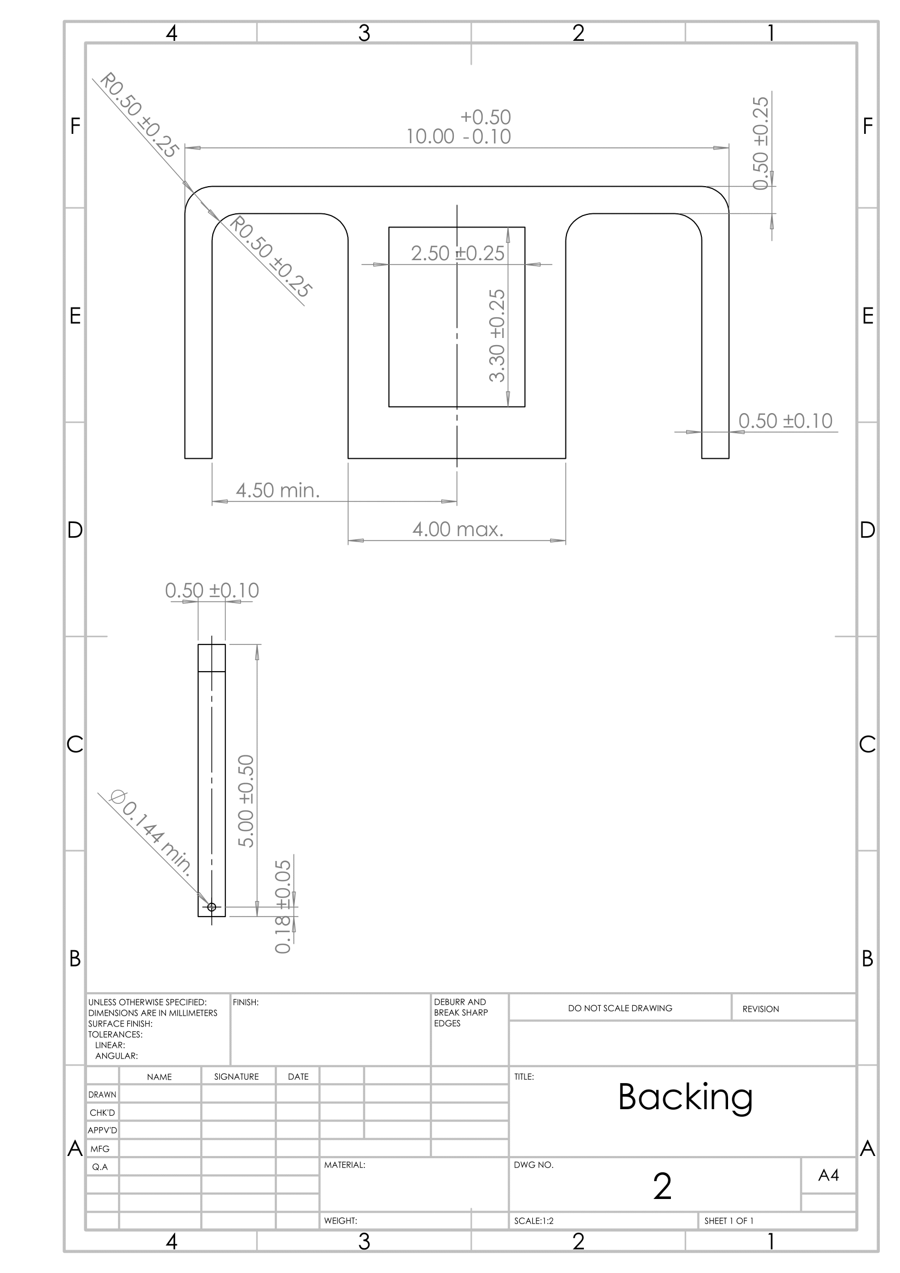

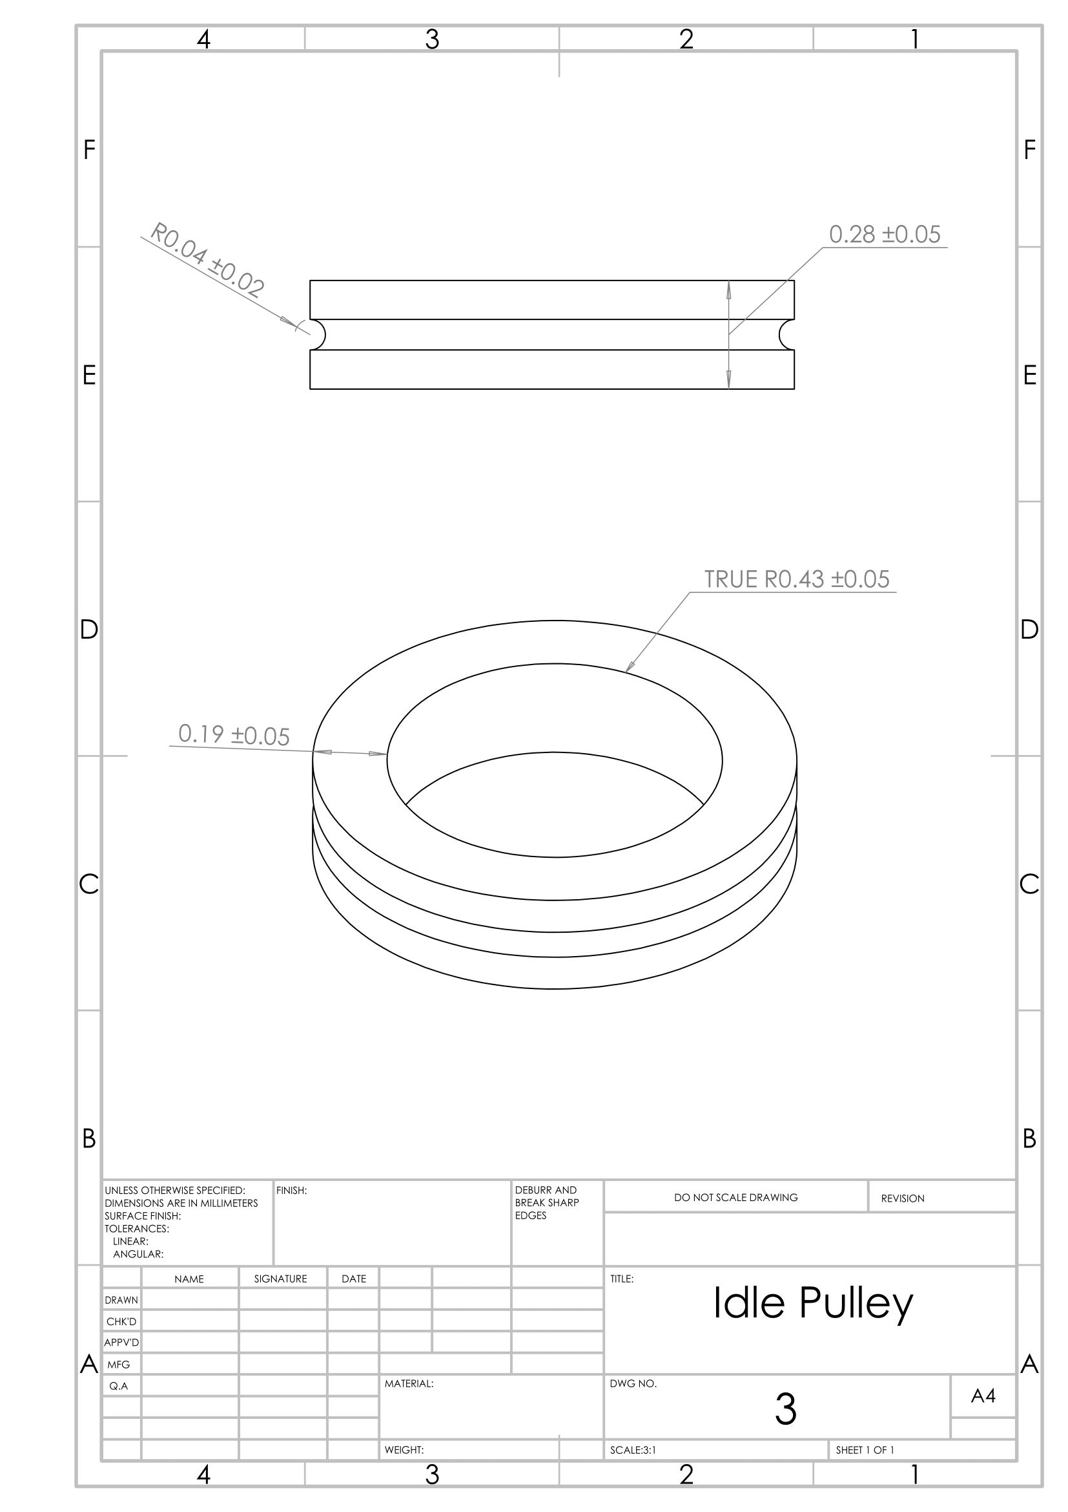

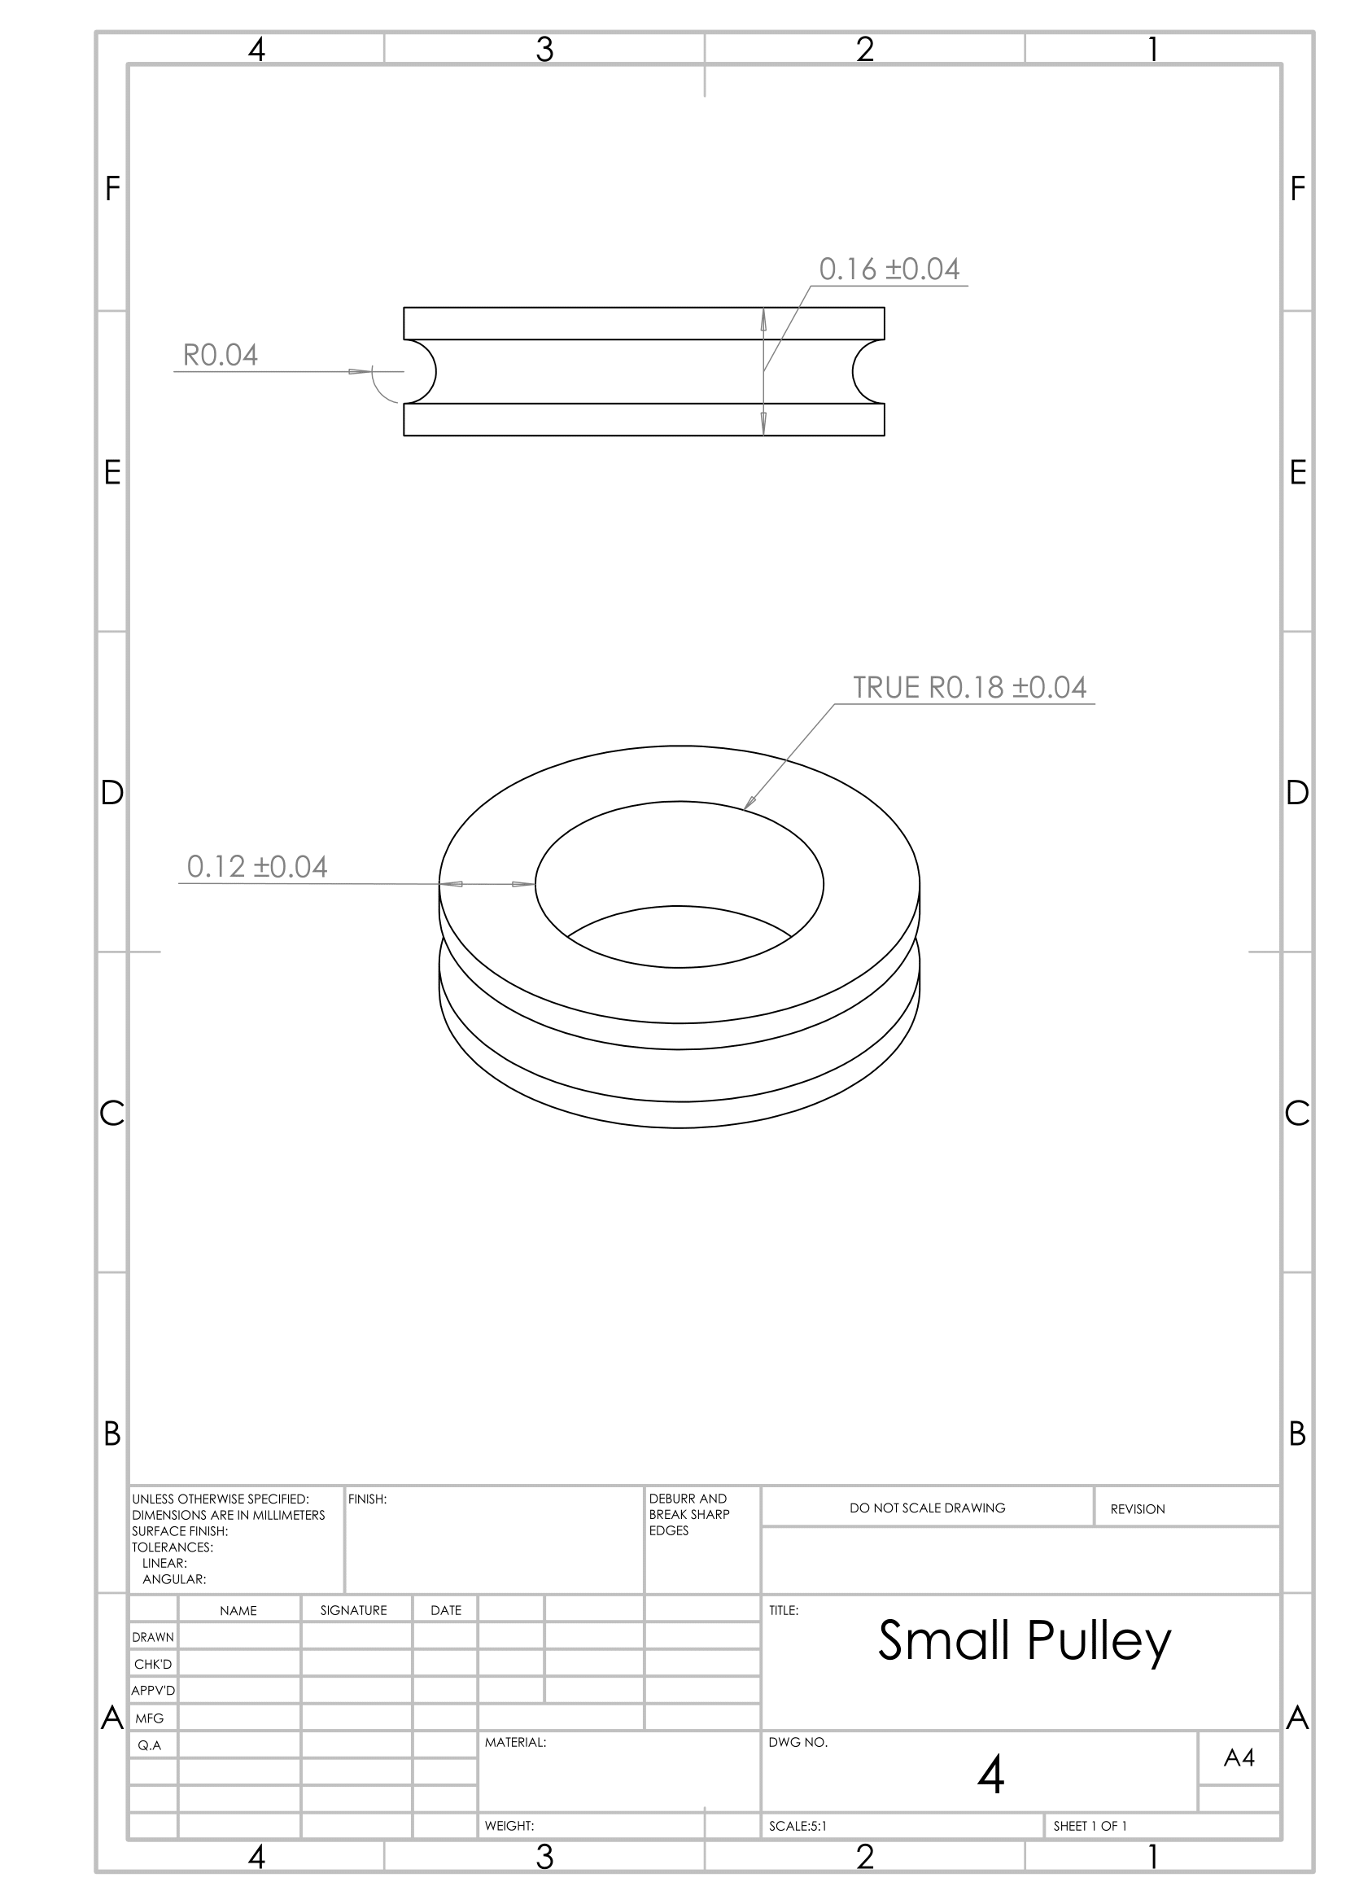

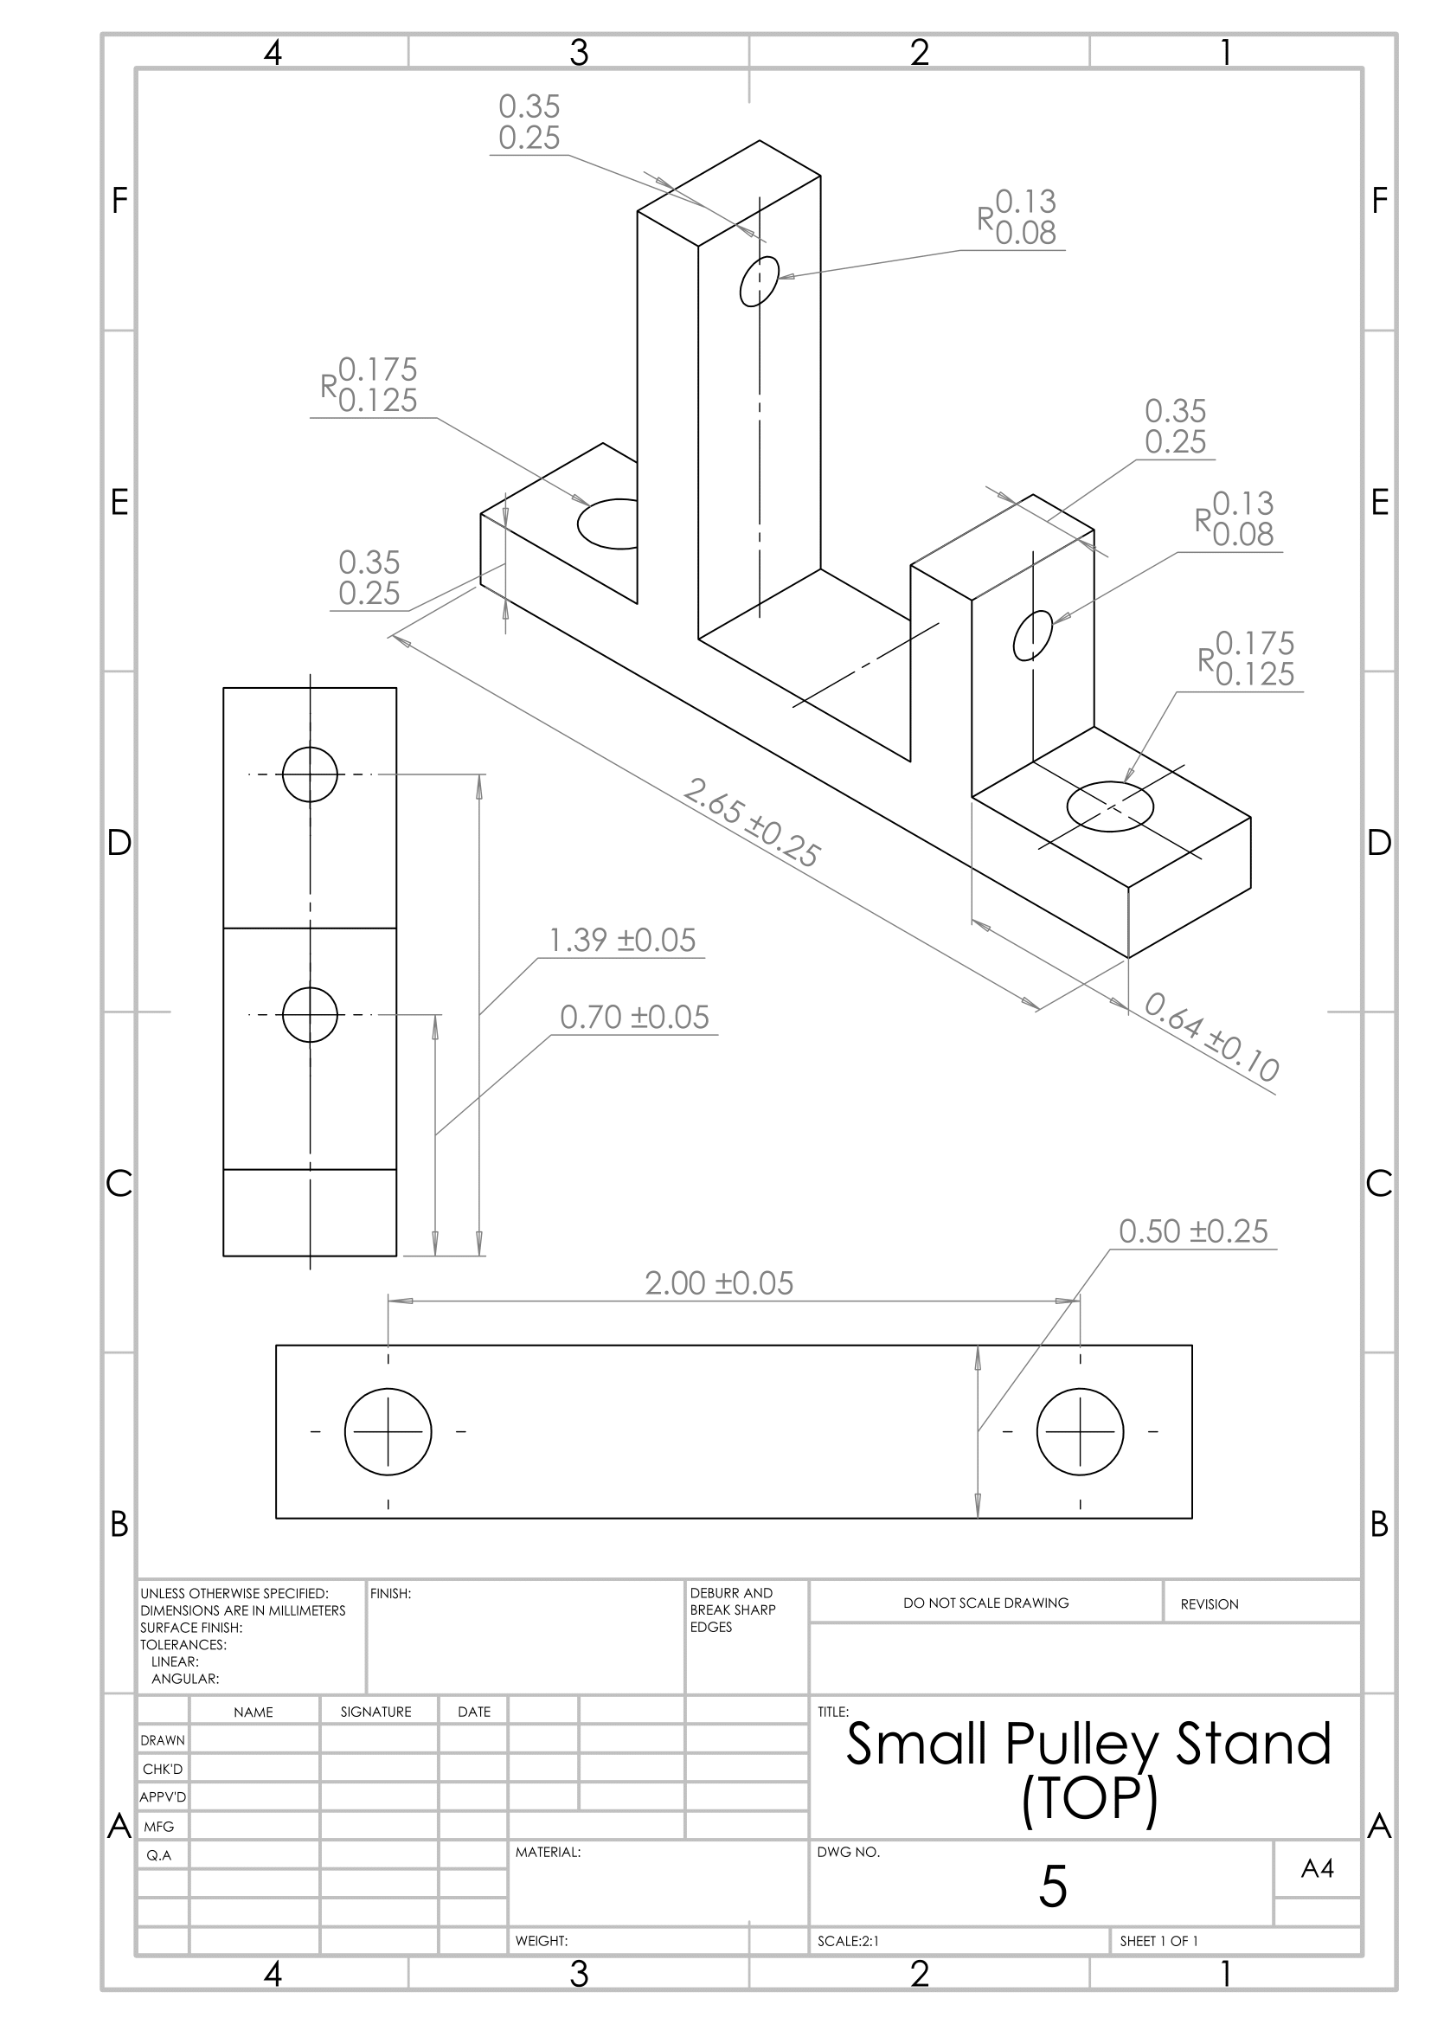

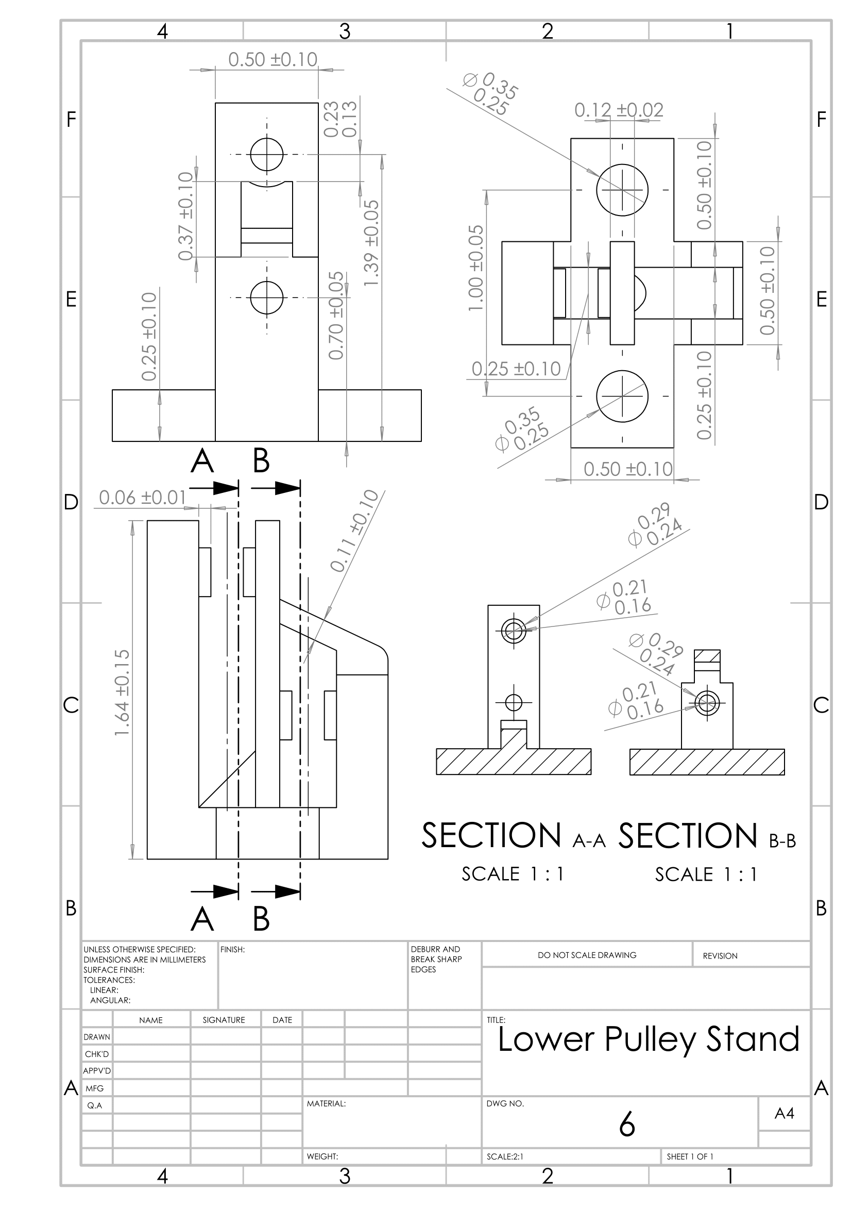

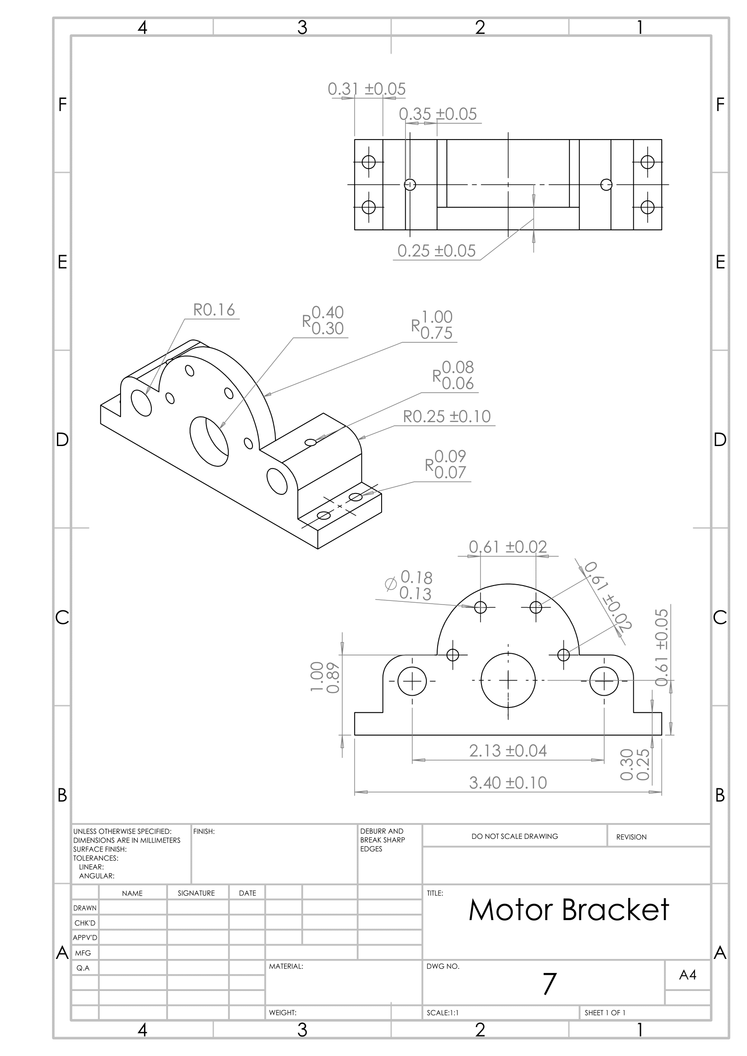

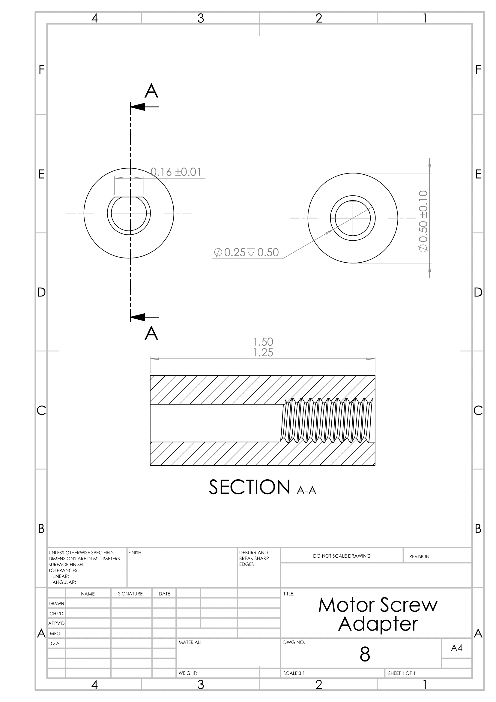

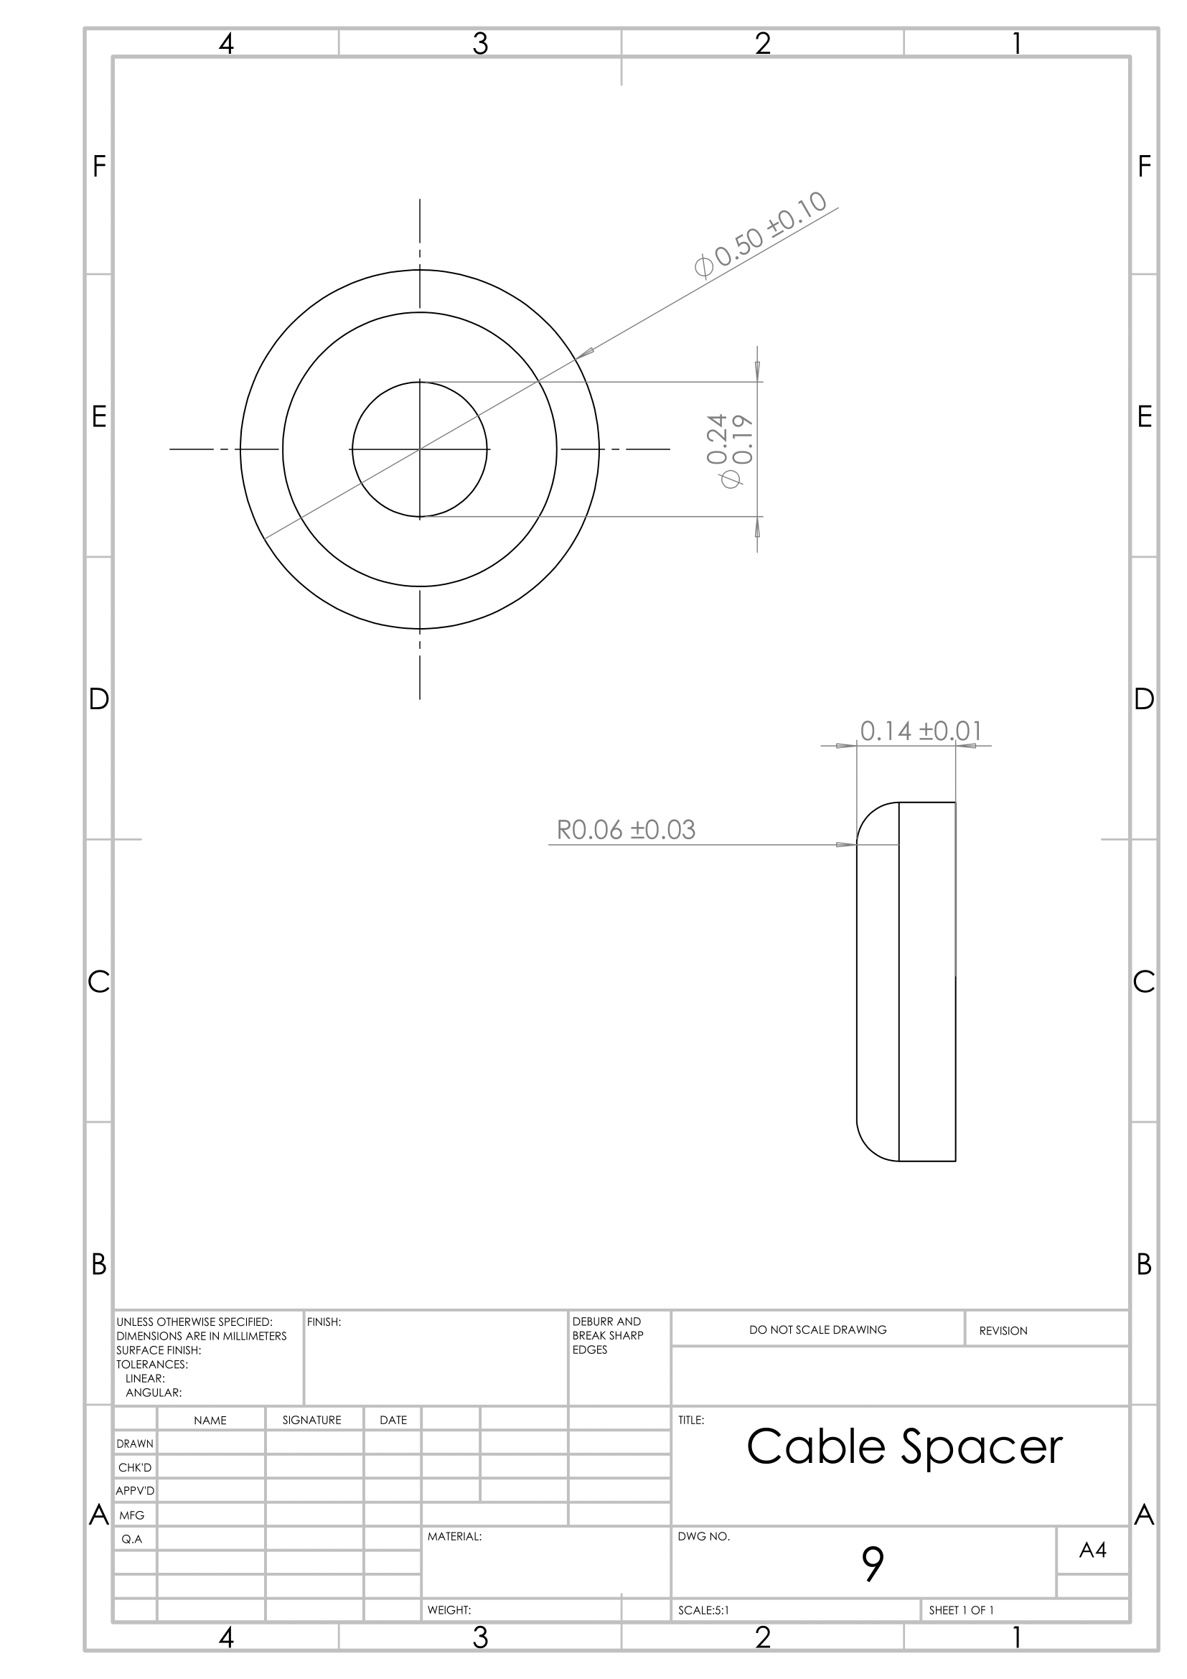

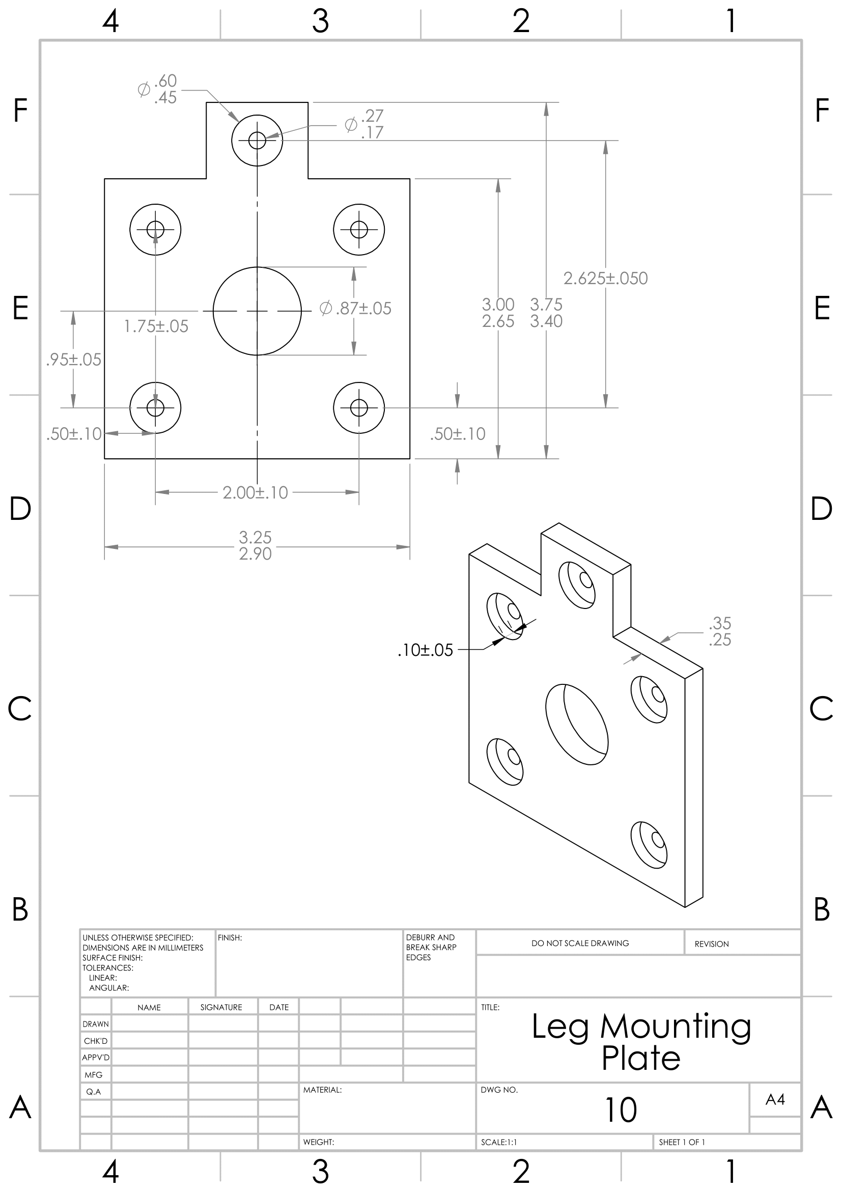

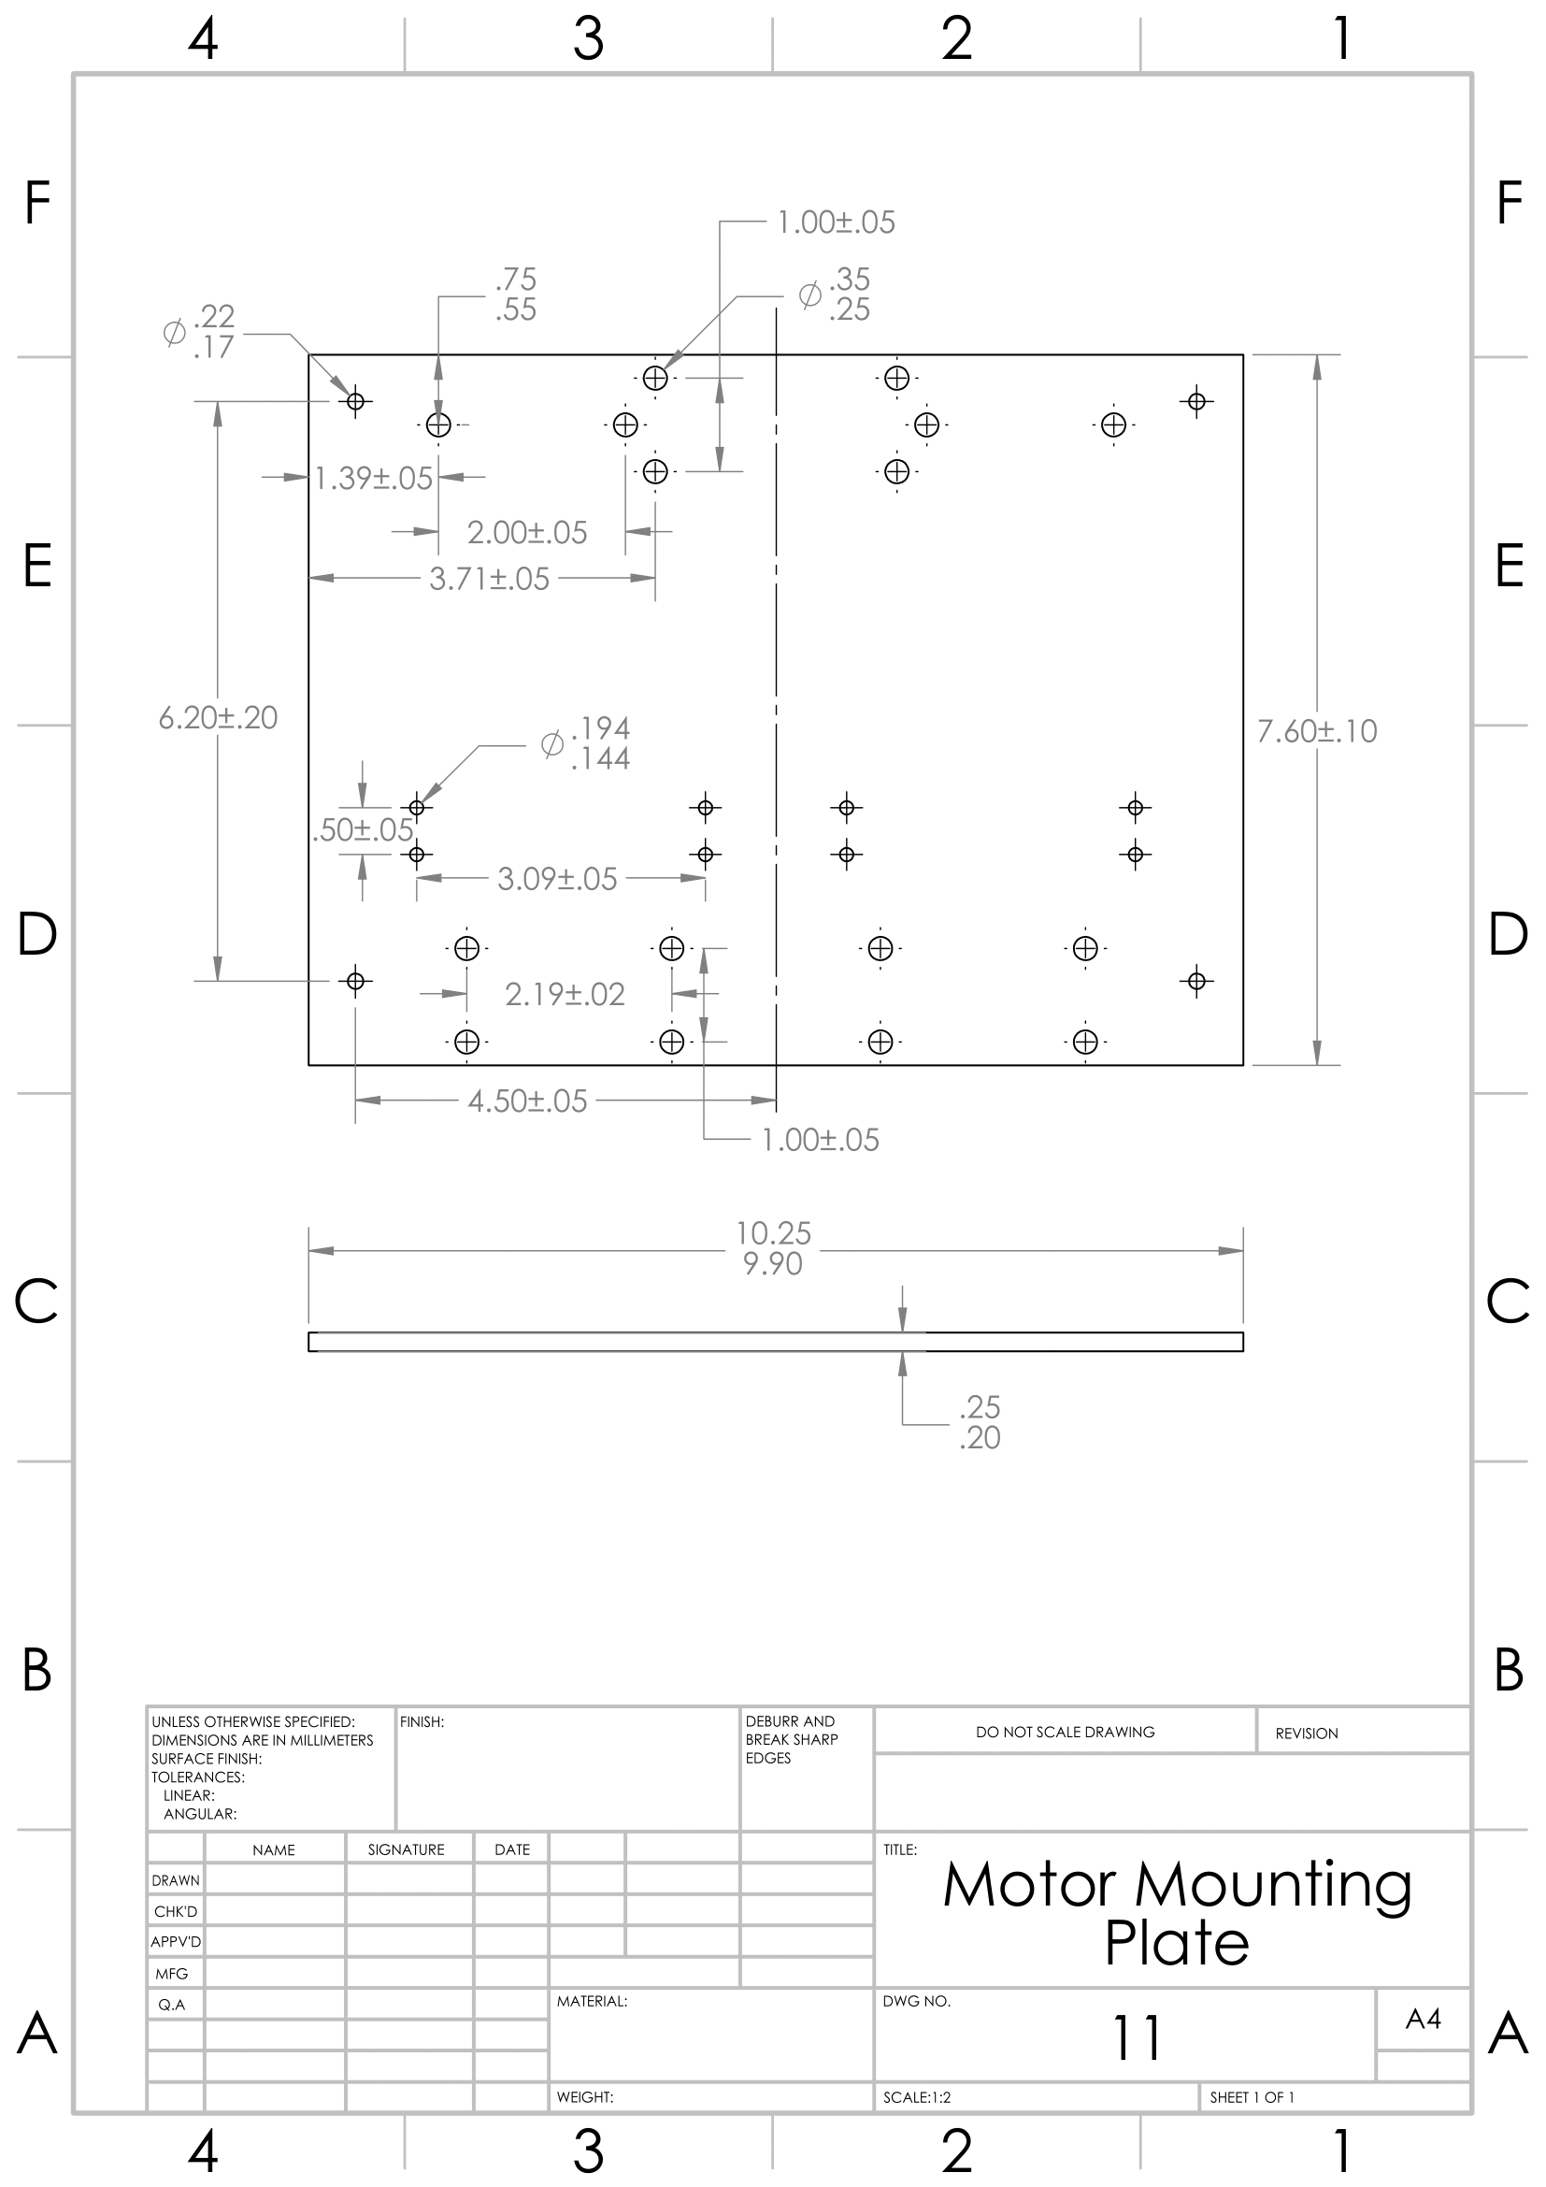

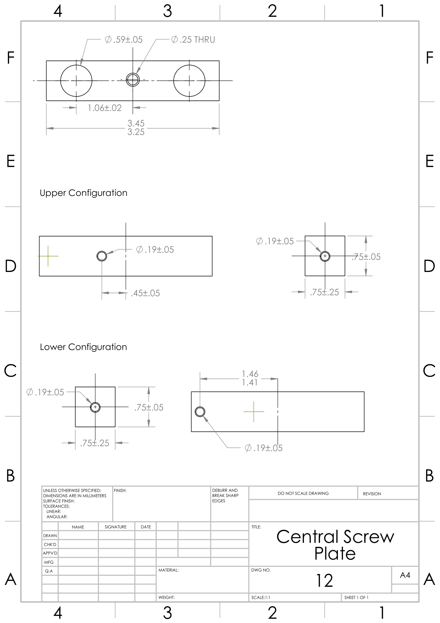

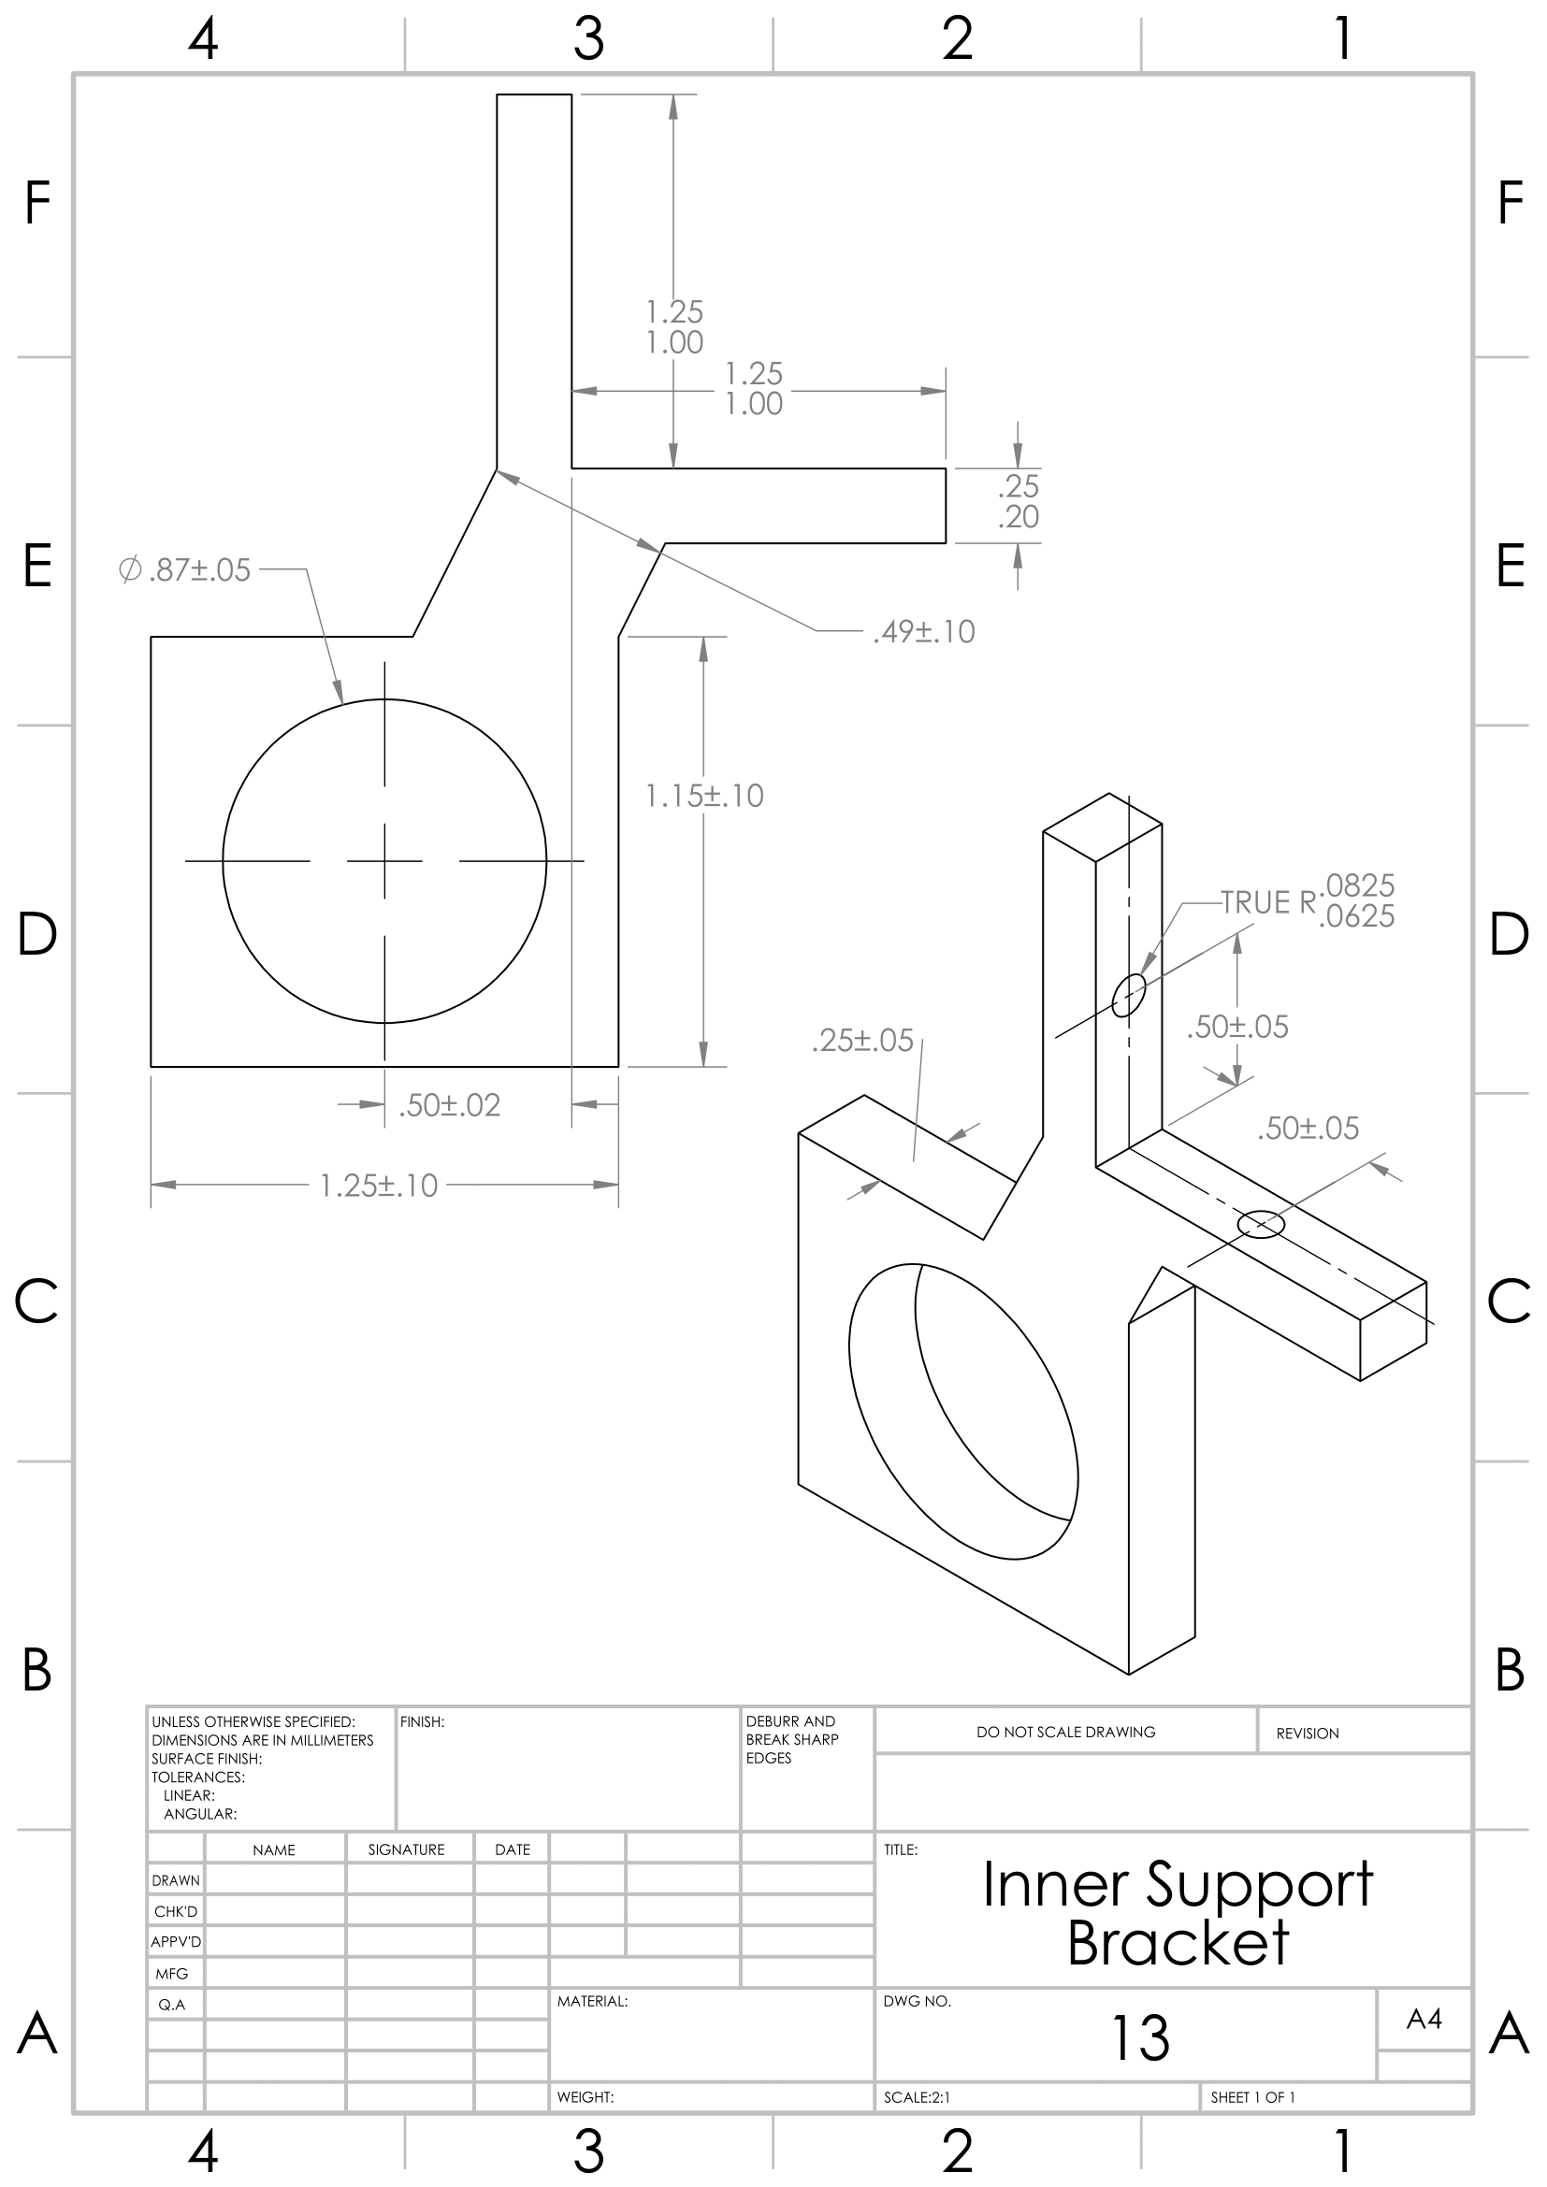

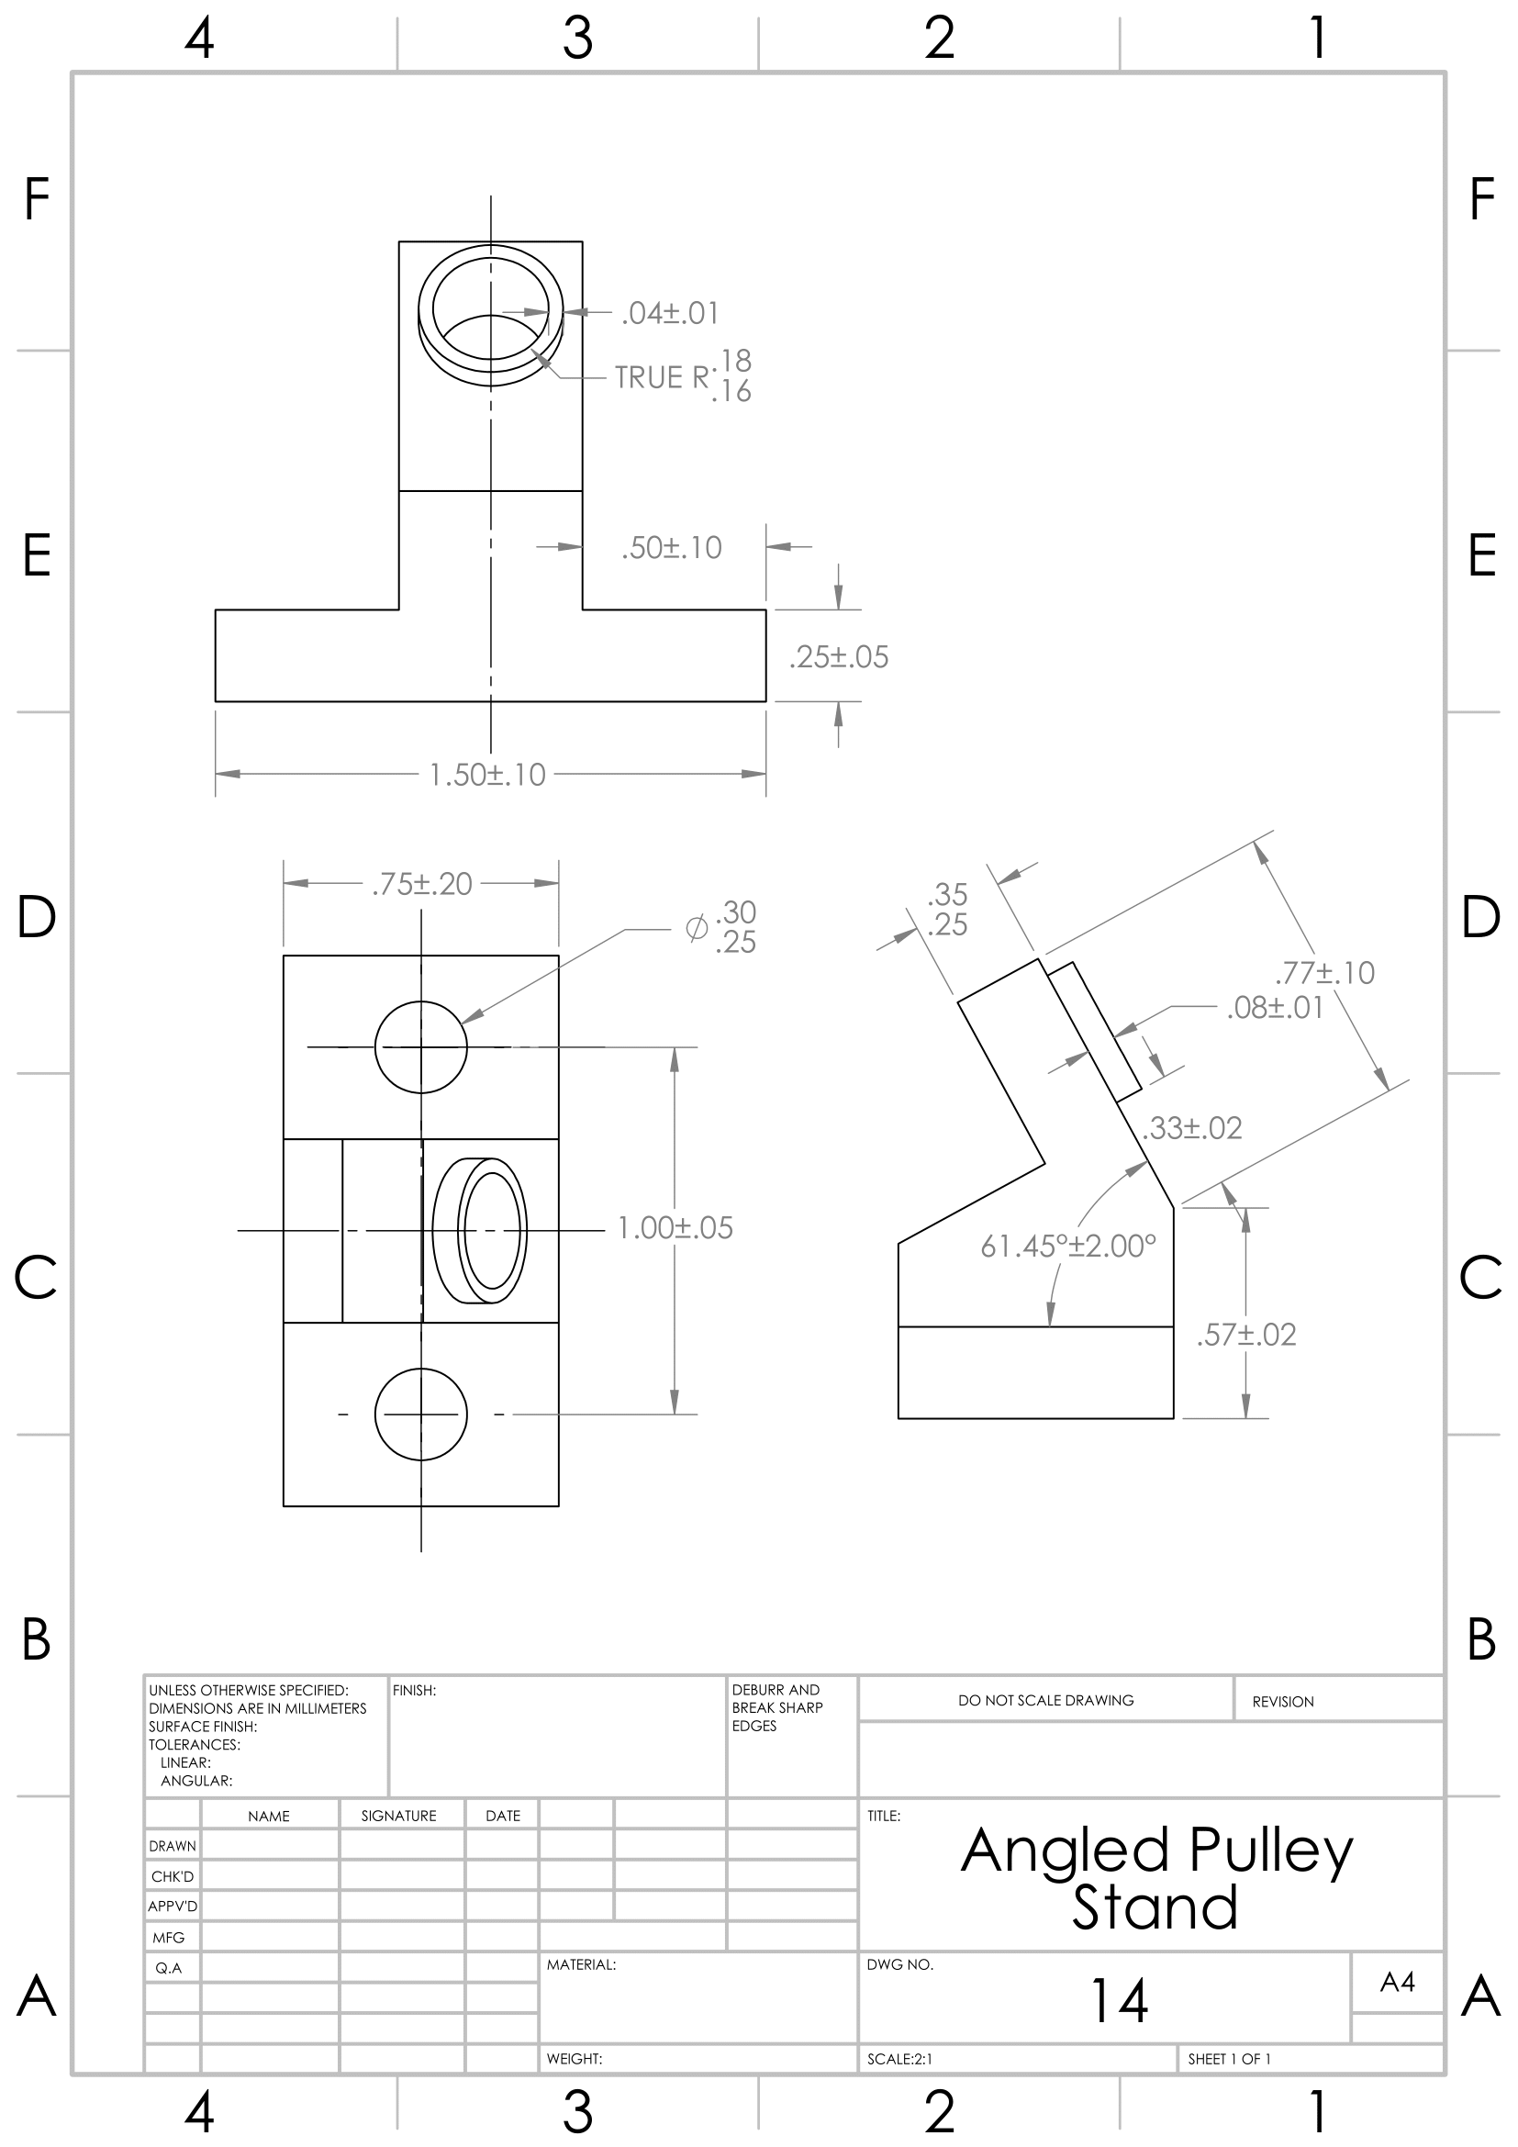

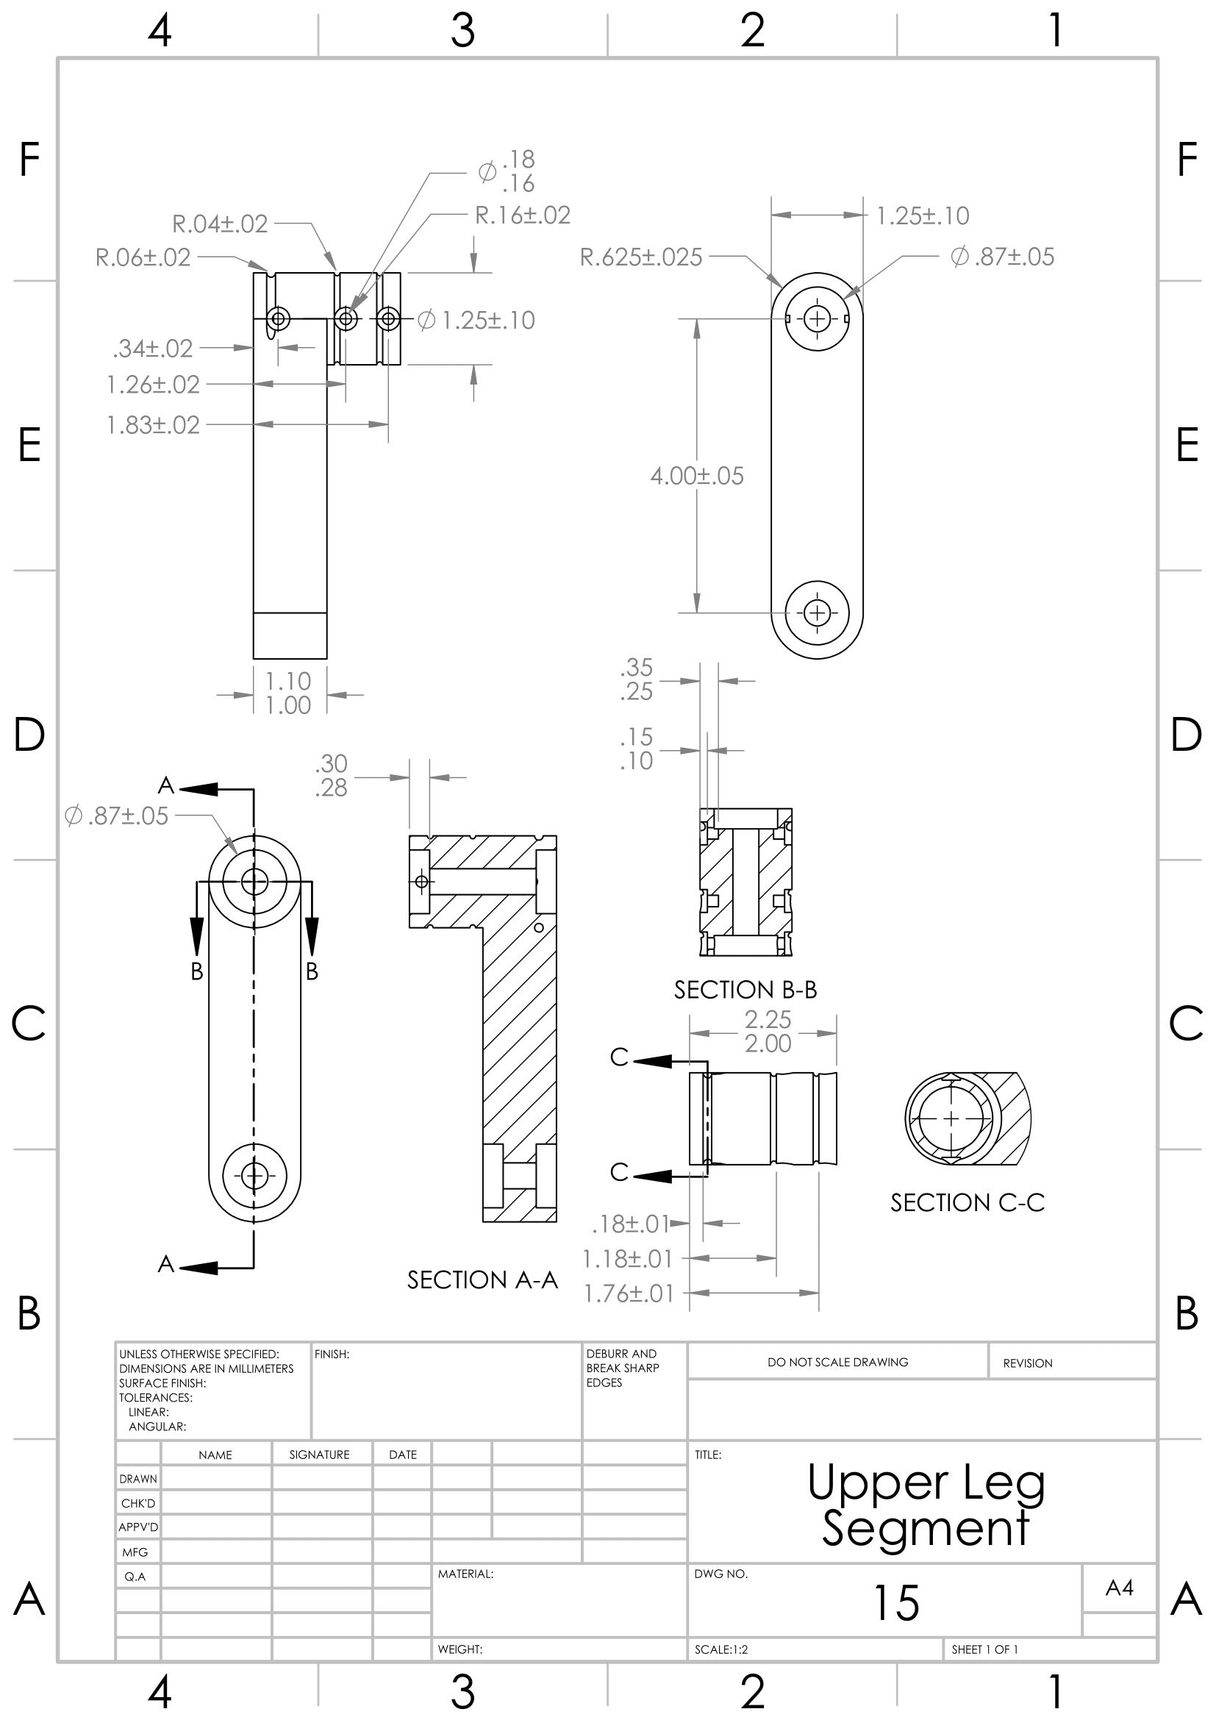

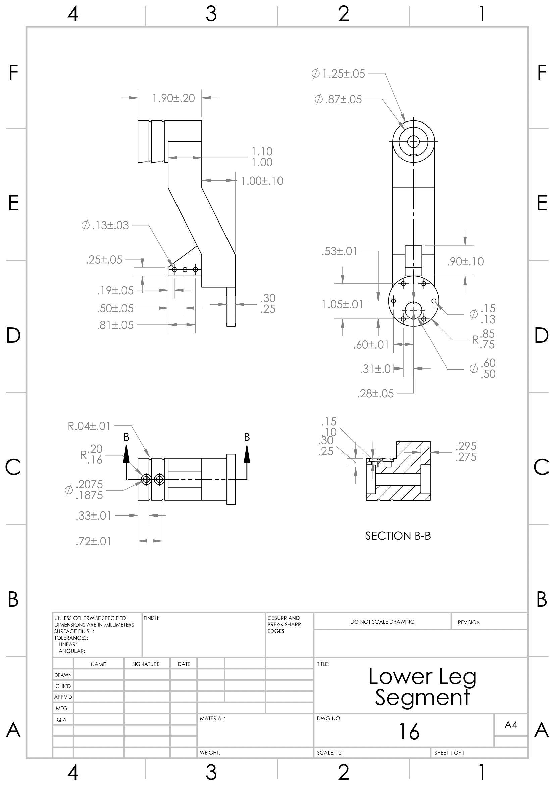

# APPENDIX B: Forward and Inverse Kinematic Equations

## B.1 Relative Positions and Rotations

|  |  |  |  |  |  |
| --- | --- | --- | --- | --- | --- |
| Vector | X (mm) | Y (mm) | Z (mm) | DCM | Rotation |
|  | x | y | z |  | rotx()roty()rotz() |
|  | 0.27714149 | 0.04295 | -0.06477 |  | roty( |
|  | 0 | 0.02794 | -0.1016 |  | roty() |
|  | 0 | 0.0357237 | -0.127762 |  | roty() |
|  | 0.27714149 | -0.04295 | -0.06477 |  | roty() |
|  | 0 | -0.02794 | -0.1016 |  | roty() |
|  | 0 | -0.0357237 | -0.127762 |  | roty() |
|  | -0.28165851 | 0.04041 | -0.06477 |  | roty() |
|  | 0 | 0.02794 | -0.1016 |  | roty() |
|  | 0 | 0.0357237 | -0.127762 |  | roty() |
|  | -0.28165851 | -0.04041 | -0.06477 |  | roty() |
|  | 0 | -0.02794 | -0.1016 |  | roty() |
|  | 0 | -0.0357237 | -0.127762 |  | roty() |

#### Table B.1: Relative Position Vectors and Rotations of the system.

## B.2 Code Repository Location

|  |  |
| --- | --- |
| Forward Kinematics Code | <https://t.ly/rRjNp> |
| Inverse Kinematics Code | <https://t.ly/A4uYE> |
| Equations of Motion Code | <https://t.ly/Setzg> |
| Open Loop Simulation Code | <https://t.ly/zsg75> |
| Closed Loop Simulation Code | <https://t.ly/mN6QB> |

Table B.2: Code Repository Location 02/22/2022-03/10/2022

# APPENDIX C: Bill of Materials

## C.1 Custom Components

|  |  |  |
| --- | --- | --- |
| **Drawing #** | **Part** | **Quantity** |
| 1 | Bed | 1 |
| 2 | Backing | 1 |
| 3 | Idle Pulley | 12 |
| 4 | Small Pulley | 16 |
| 5 | Upper Pulley Stand | 4 |
| 6 | Lower Pulley Stand | 4 |
| 7 | Motor Bracket | 8 |
| 8 | Motor Screw Adapter | 8 |
| 9 | Cable Spacer | 8 |
| 10 | Leg Mounting Plate | 4 |
| 11 | Motor Mounting Plate | 2 |
| 12 | Screw Plate | 8 |
| 13 | Inner Support Bracket | 4 |
| 14 | Angled Pulley Stand | 8 |
| 15 | Upper Leg Segment | 4 |
| 16 | Lower Leg Segment | 4 |

#### Table C.1: Custom Components

## C.2 Fasteners

|  |  |  |  |
| --- | --- | --- | --- |
| **Fastener** | **Nuts** | **Washers** | **Quantity** |
| ¾” M5 Screw | 0 | 30 | 30 |
| 1 ¼” #6 Bolt | 2 | 4 | 2 |
| ¾” 0.25 Bolt | 32 | 64 | 32 |
| 1” #6 Bolt | 16 | 32 | 16 |
| 3/16” #5 Screw | 0 | 0 | 16 |
| 1” M5 Bolt | 8 | 16 | 8 |
| ¾” M5 Bolt | 8 | 16 | 8 |
| ½” #10 Screw | 0 | 16 | 16 |
| ¾” M8 Bolt | 8 | 16 | 8 |
| 9mm M3 Screw | 0 | 0 | 48 |

#### Table C.2: Fasteners Components

# A diagram of a press emergency button Description automatically generatedA diagram of a program Description automatically generatedAPPENDIX D: Control Flow Chart

# APPENDIX E: Average Couch and Bookshelf Weights and Dimensions

## E.1 Bookshelves

|  |  |  |  |  |  |
| --- | --- | --- | --- | --- | --- |
| **Bookshelf** | **Weight(lbs)** | **Width(in)** | **Depth(in)** | **Height(in)** | **Reference** |
| A-Saratoga | 56.05 | 29.88 | 12.5 | 71.53 | [11] |
| B-Edenbrook | 81 | 31.5 | 12.8 | 72.8 | [12] |
| C- Cherry | 78.8 | 33 | 11.6 | 59.8 | [13] |
| D - Farini | 86.8 | 33 | 11.6 | 59.8 | [14] |
| E- Rolanstar | 14.03 | 23.62 | 13.78 | 63 | [15] |
| Average | 65.45 | 30.09 | 12.52 | 65.36 |  |
| Average (Scaled) | 1.023 | 7.52 | 3.13 | 16.34 |  |

#### Table E.1: Bookshelf Characteristics

## E.2 Couches

|  |  |  |  |  |  |
| --- | --- | --- | --- | --- | --- |
| **Couch** | **Weight(lbs)** | **Width(in)** | **Depth(in)** | **Height(in)** | **Reference** |
| A-Leisland | 120 | 88.58 | 33.07 | 27.5 | [16] |
| B-Van Acc | 100 | 89 | 36 | 35 | [17] |
| C-Ashley | 238 | 88 | 36 | 40 | [18] |
| D-Mcombo | 250 | 92 | 36 | 41 | [19] |
| E-Jennifer Taylor | 110 | 88 | 37 | 32.5 | [20] |
| Average | 163.6 | 89.116 | 35.614 | 35.2 |  |
| Average (Scaled) | 2.55625 | 22.279 | 8.9035 | 8.8 |  |

#### Table E.2: Couch Characteristics

## E.3 Stairway Dimensions

|  |  |
| --- | --- |
| **Inside STEM – Front Staircase Dimensions** | |
| Stair Total Height | 130in |
| Tread Depth | 11.94 |
| Upper Landing Depth | 48.5in |
| Step Height | 7in |
| Total Stairway Width | 72in |
| Usable Stairway Width | 66in |

#### Table E.3: Dimensions of Stairs in Bldg. 76

# APPENDIX F: Electrical Schematic

## F.1: TOP LEFT

## F.2: TOP MIDDLE

## F.3: TOP RIGHT

## F.4: BOTTOM LEFT

## F.5: BOTTOM MIDDLE

## F.6: BOTTOM RIGHT

# A screenshot of a computer Description automatically generatedAPPENDIX G: Printed Circuit Board (PCB) Layout

# A diagram of a flowchart Description automatically generatedAPPENDIX H: System Flowchart

# APPENDIX I: Dynamics Simulation and Control

## I.1 Uncontrolled Simulated Leg Angles

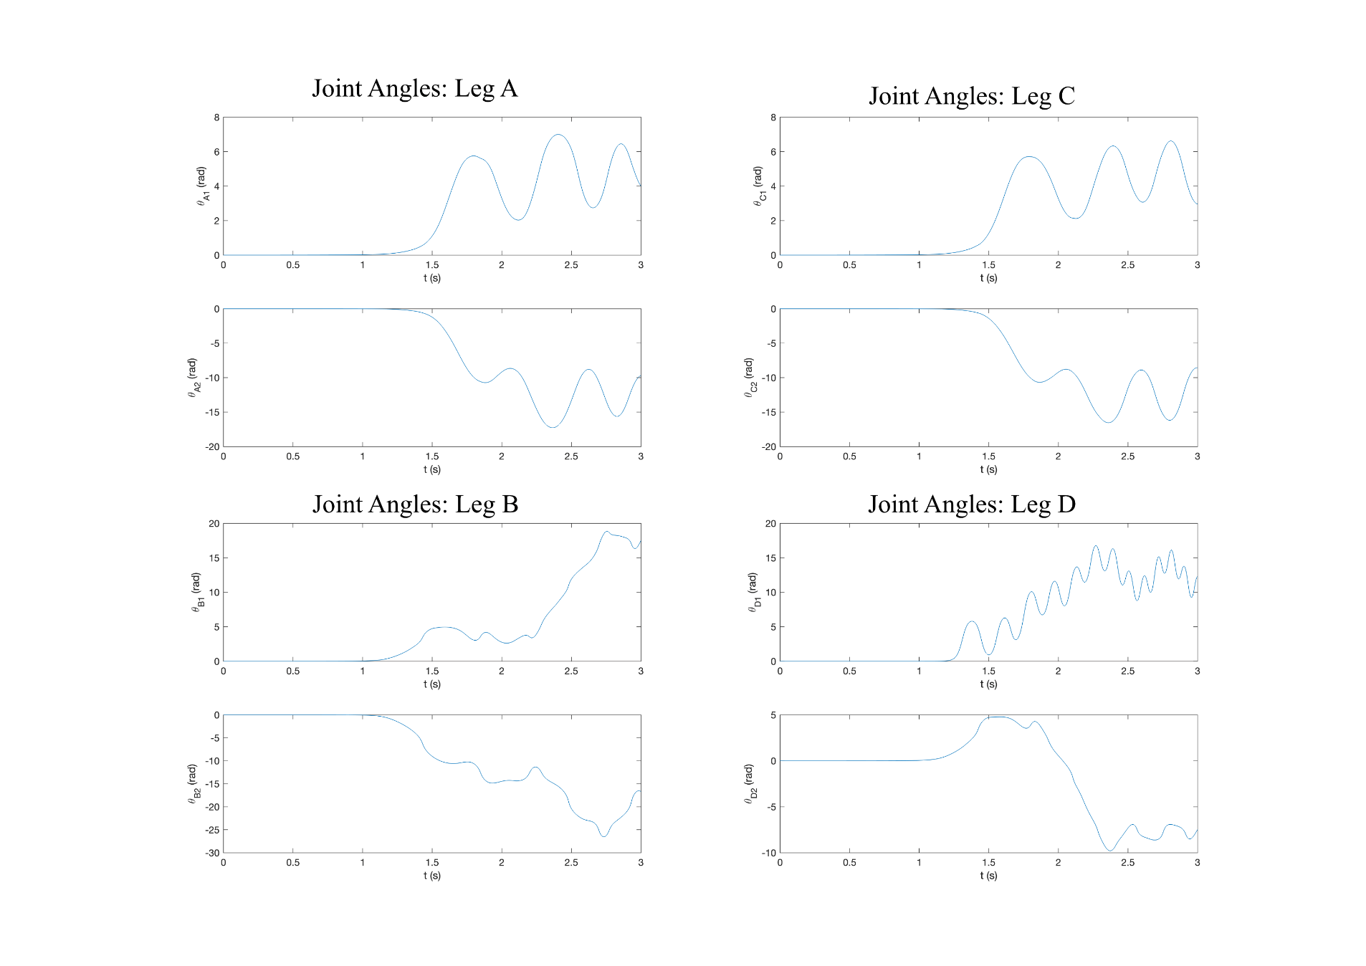

Figure I.1: Plots of Uncontrolled Leg Angles

## I.2 Leg Angular Velocities

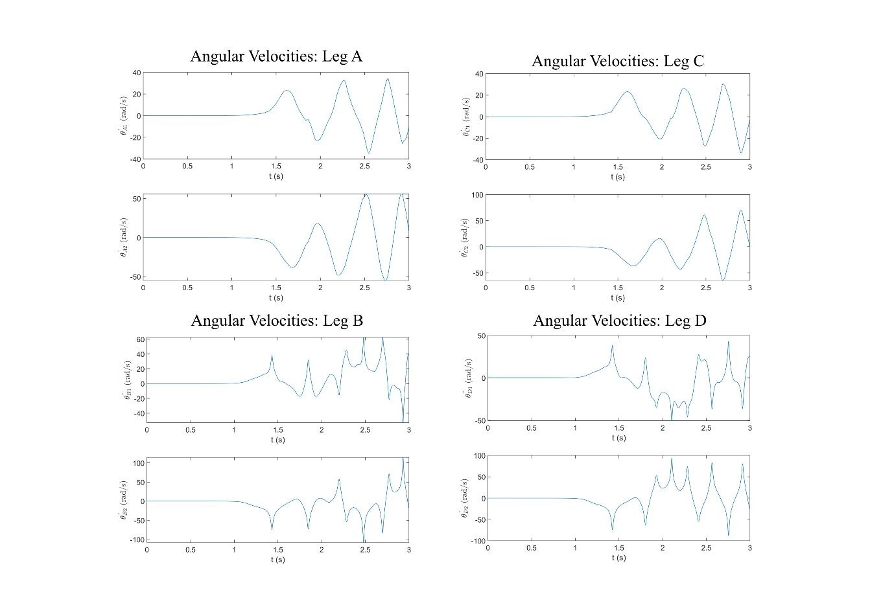

Figure I.2: Plots of Uncontrolled Leg Angular Velocities

## I.2 Leg A Controlled Angles

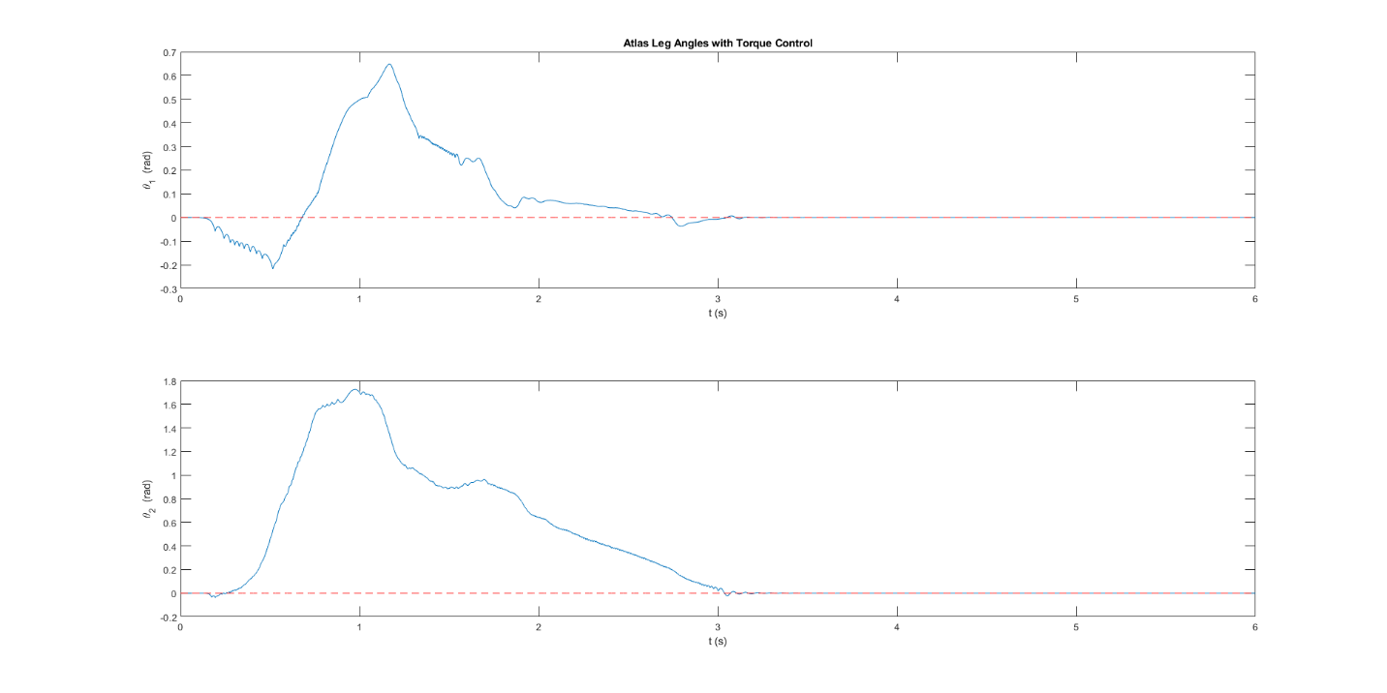

Figure I.3: Controlled Leg Angles

ATTRIBUTIONS

|  |  |
| --- | --- |
| Contributor | Contribution |
| Ian Adelman | Sections 3.3.1 – 3.7 |
| Devin Hoopes | Sections 3.1-3.3, 3.6-3.7 and 6 |
| Natalie Gonzalez | Sections 1-2 and 5 |
| Alex Reinert | Section 4 |